Security eForm. How to initiate a request for self?

- Start by logging in to Campus Solutions.


- Ensure you can see the CS security form icon. If you don’t see the icon, please email sa-security@uh.edu with your emplid.
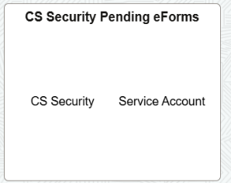
- ‘Start Security Access Request’ from the left-hand menu.
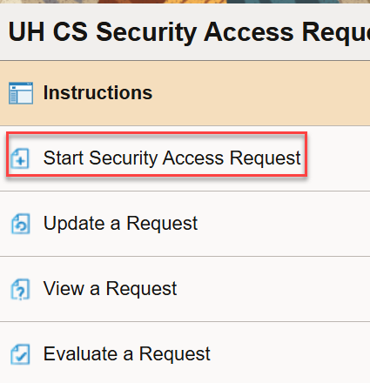
- The following screen comes up. Validate items 1 through 6.

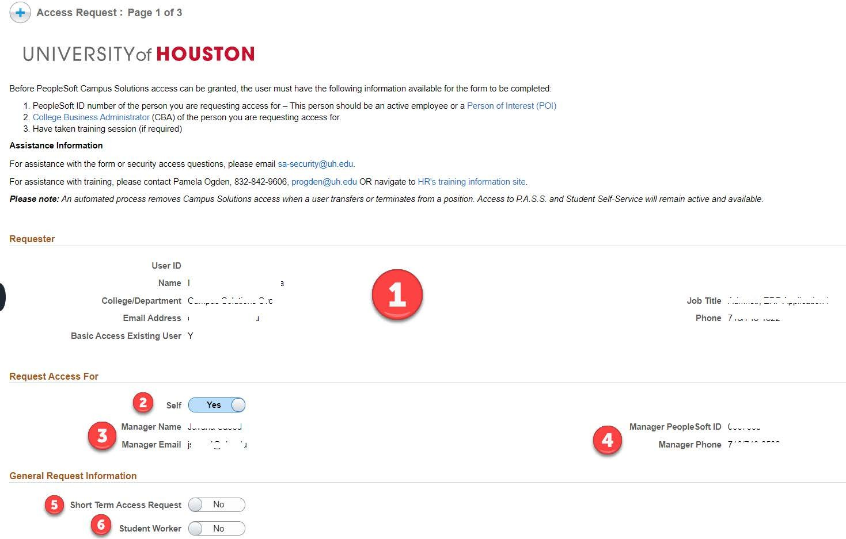

- Click ‘Next’

- Following screen comes up. For items 1 and 2, if you need full access to either DOB or SSN, please complete the justification box, which will pop up. Toggle buttons 3 to 11 to request access for the
respective modules.
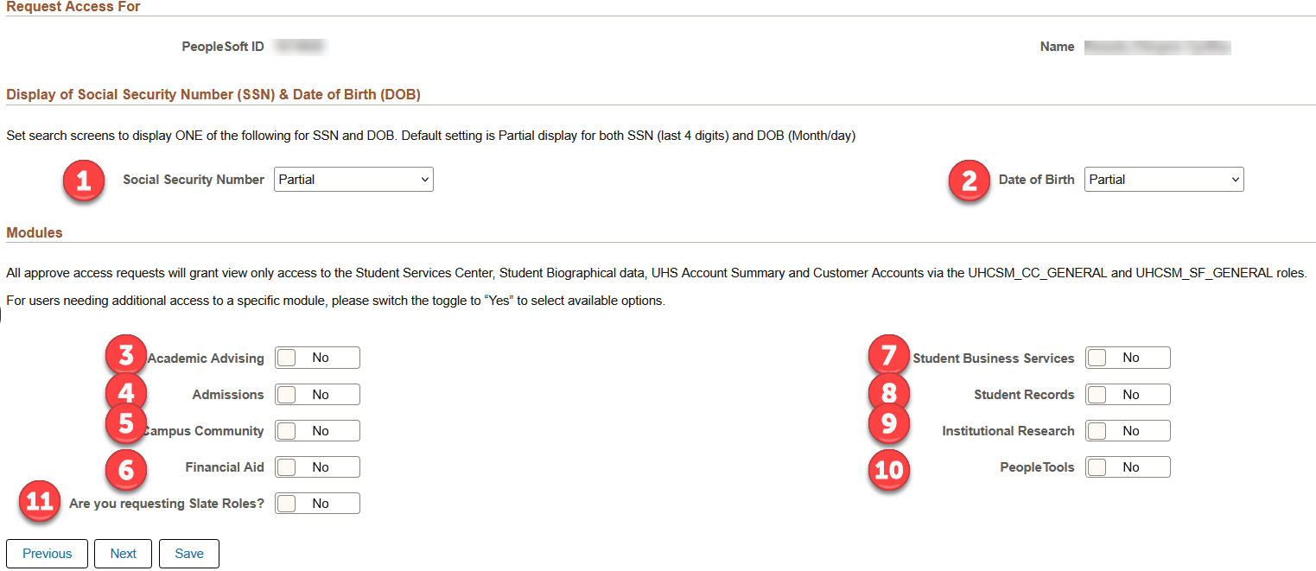
- If you toggled yes for a module, the page would expand to show access options for the selected module/s.
For each of the access toggled in area marked 1, you can find its required training in area 2. If the access you are looking for is not on a toggle, you can use the ‘other’ (marked as 3) box to write in the access needed. Click Next.

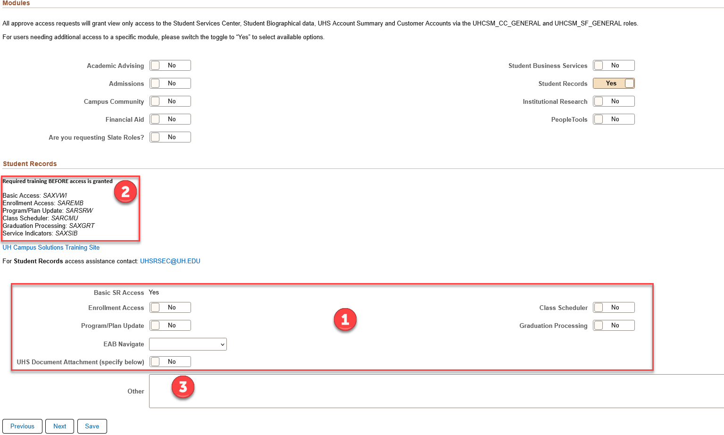

- If you toggled yes for module 11 (‘Are you requesting Slate Roles?’), the next page shows the Slate Roles and Permissions to be requested. Click Next.

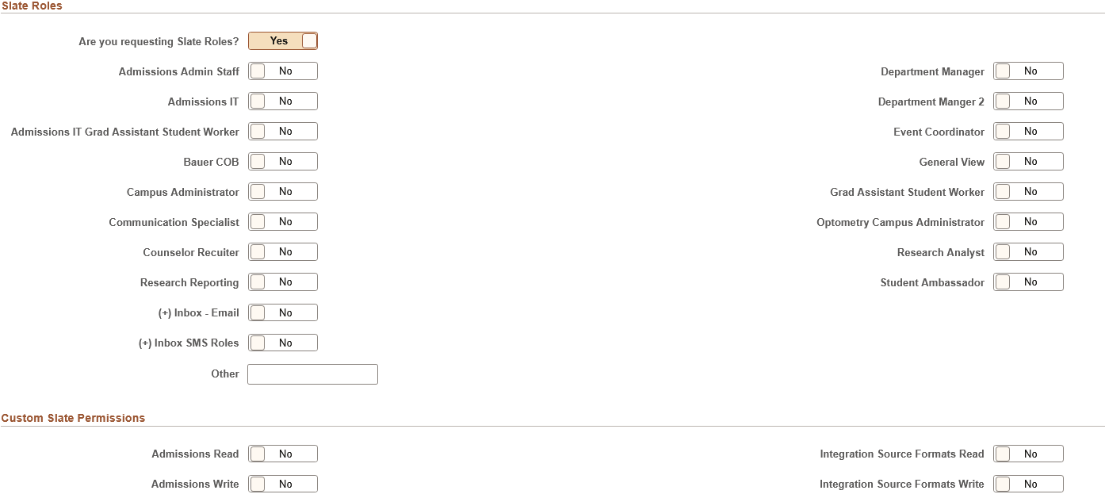

- Complete the Acknowledgement section. Click Submit. Once the form is submitted, it is routed to your Manager for approval.
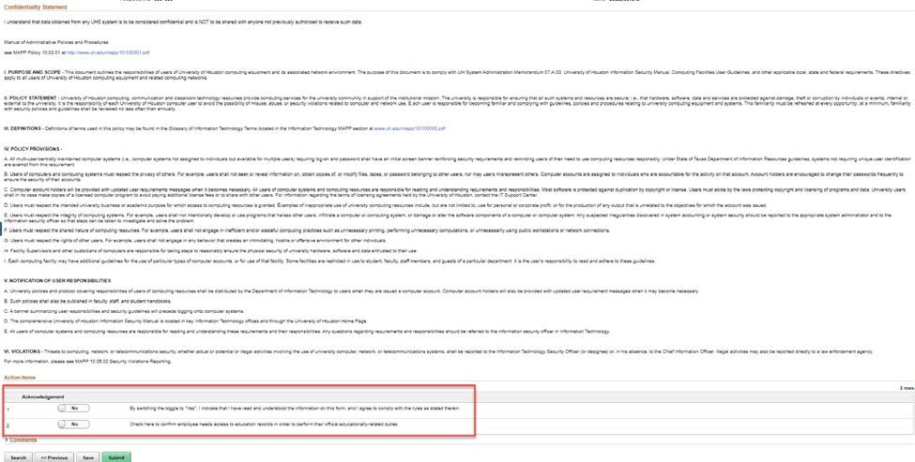

FYI. Once your access has gone through all the approvals, and the Campus Security Administrator(s) (CSA) has processed your request, it is considered complete. You will receive an email like the following:

