Manager Approval Instructions
Managers can either approve, modify and approve, or decline an access request. Campus Solutions security access can now be requested electronically.

- Once one of your direct reports submits an access request for Campus Solutions, using electronic version of the security form (security eForm), you will receive a similar email, as their Manager:

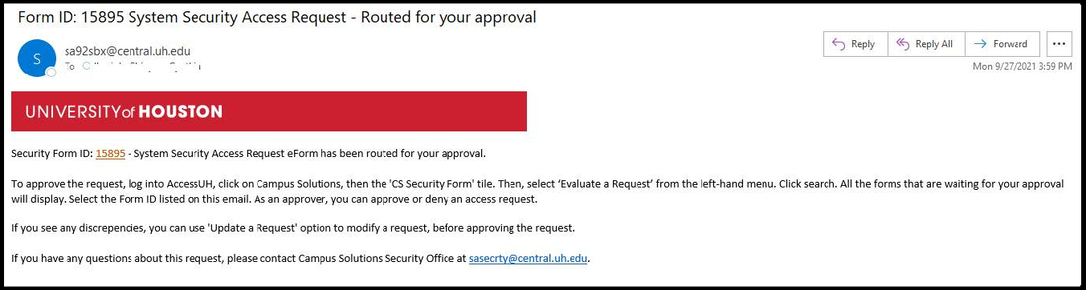

- You can access the form by following steps a through c.
  - Log into Campus Solutions in any browser.
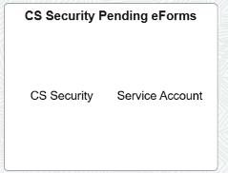
  - Ensure you can see the CS security form icon.
If you don’t see the icon, please email sa-security@uh.edu with your emplid.

  - Select ‘Evaluate a Request’ from the left-hand menu and click “Search”.
All the forms that are waiting for your approval will show up. Select the appropriate form from the list.

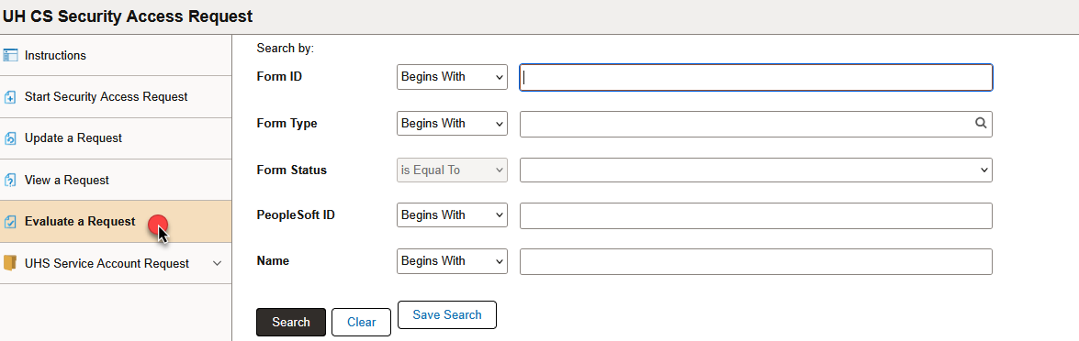

- Following screen comes up. Validate items 1 through 4. Please ensure all the information on this page is correct.

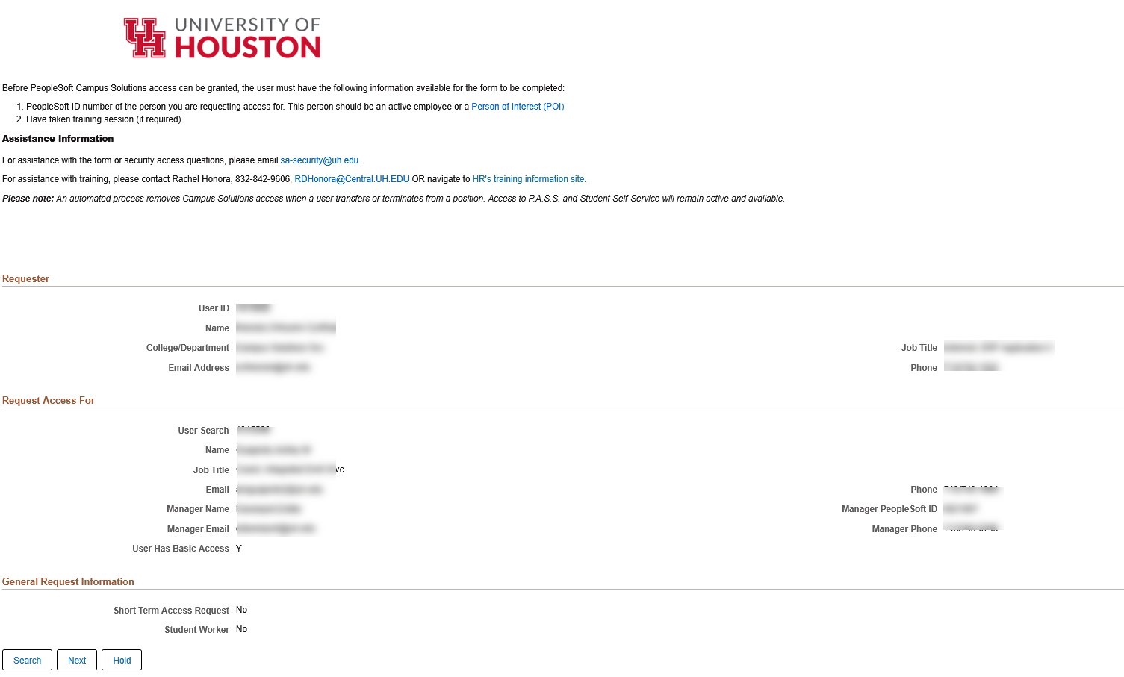

- Click ‘Next’
- The following screen comes up. For items 1 and 2, please validate that the employee has selected correct level of access. All the employees get partial access to SSN and DOB as default. For full access to either DOB or SSN, justification is needed. For less than partial access, no justification is needed. Employees only need to select access under the modules if they needs more than basic access. Click approve.

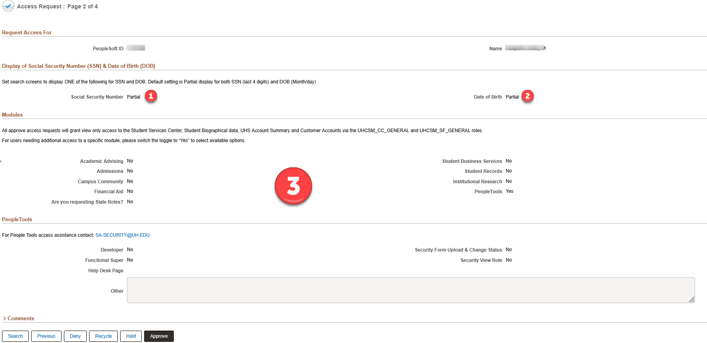

Upon clicking the approval button, you will see a screen like below:

