How to view an existing request.
The latest status of any security eForm can be seen using the steps below:

- Start by logging in to Campus Solutions.

- Ensure you can see the CS security form icon. If you don’t see the icon, please email sa-security@uh.edu with your emplid.
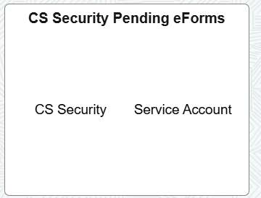

- Select ‘View a Request’ from the left-hand menu. You can use any of the criteria in the red box to search for a particular form.

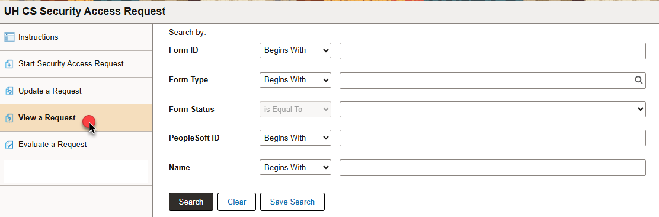

- Following screen comes up. You can quickly identify the status of the form from the form status field, boxed in
red.
  - Pending: The form is waiting for the next approval.
  - Save: The form has not been submitted yet. It is still with the initiator.
  - Withdrawn: The form has been withdrawn.

- Executed: The form has completed its workflow. A new request should be initiated for new security request.

