Summer 2020
Cougar Communication Pals (CCPals)

ENROLLMENT PACKET

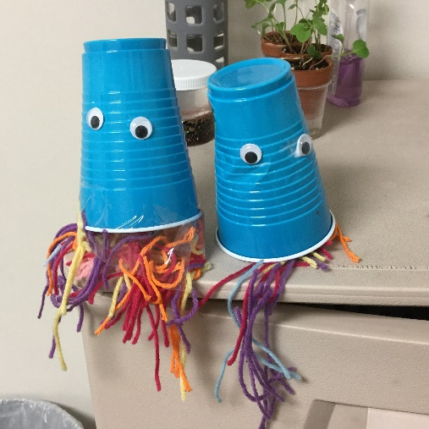

Thank you for your interest in Cougar Communication Pals (CCPals) for the summer of 2020. This program is provided by the University Speech-Language-Hearing Clinic: A United Way agency (USLHC) and provides evidence-based therapy through telepractice for children ages 2 to 14 years of age. Children will work on individualized goals which will be achieved through fun activities, such as story-time, art, science, cooking, and music. Teletherapy is provided by Communication Sciences and Disorders graduate students under the supervision of licensed and certified speech-language pathologists.

Tuition is $50 per session. A sliding scale based on income is available to families that qualify. Please request a fee reduction application form when submitting your registration form to the following email: uslhc@central.UH.EDU. Credit card payments will be collected weekly via the telephone. Our financial coordinator will call you weekly at a designated time to collect payment. Call 713-743-0915 if you have any questions.


Mailing a payment?
Please mail checks/money orders to:
University Speech, Language & Hearing Clinic
4455 Cullen Blvd. Room 102
Houston, TX 77204-6018

2020 Summer Program Registration Packet

Client Name: _____________________

Checklist of items to submit to the

University Speech-Language-Hearing Clinic:

- Client contact information form
- Scheduling preference
- ARD paperwork if coming from a school district
- Recent speech/language testing reports
  - Within 3 years if from a school district
  - Within 1 year if from a clinic/hospital
- Case History form *access via link on website*
  - All admission is pending a recent evaluation. If you are a new client, our clinic will contact you to schedule an evaluation.
- Observation release
- Contract for services
- All About Me page

Please complete forms and email to: USLHC@uh.edu



Client Contact Information/

Información de Contacto del Cliente

_________________________________
Date / Fecha

________________________________ _________________________________
Client Name / Nombre del cliente Street address / Dirección

________________________________ _________________________________
Guardian name / Relationship / City, state, zip / Ciudad, estado, código postal
Nombre del tutor / Relación con el cliente

________________________________ _________________________________
Guardian name / Relationship / Home phone / Teléfono de casa
Nombre del tutor / Relación con el cliente

_________________________________
Work phone / Teléfono de trabajo

________________________________
Cell phone / Teléfono móvil

________________________________
Email / Correo electronico

2020 Summer Program

Scheduling Form

GROUP SELECTION:
Children attending the summer program may be organized into pairs with other children working on similar goals. Therapy for the summer will target the most important goal area for each client. These goals will be determined by considering input from parents, clinicians, previous clinicians, and diagnostic results.

1. Please list languages spoken by your child:

2. Please circle current speech and/or language goals that have been identified for your child. If you have more than 1 please number (1-3) with number 1 as the greatest need, and the number 3 as the least of need

- Vocabulary | - Articulation (speech sounds)
- Reading | - Following Directions
- Planning and sequencing activities/ideas | - Voice Quality
- Communication with AAC Device | - Grammar
- Fluency | - Social Skills

3. Please list any concerns you have regarding your child’s speech and language skills:

4. What is your child’s current medical diagnosis/disability?

5. I would like my child to be paired with a Pal. _______ YES _______ NO (please check one)

SCHEDULING

Graduate clinicians are required by the American Speech-Language-Hearing Association (ASHA) to be supervised 100% of the time by a licensed and certified speech-language pathologist (clinical educator) when providing services via telepractice. As such, days and times are dependent on clinician and clinical educator availability. However, we will work to accommodate your schedule as much as possible. Please indicate your preferred days and times by inserting the times you are available in the table below:

Days | Monday | Tuesday | Wednesday | Thursday | Friday
Example: | 2:00pm | 10:00am | Not available | 10:00am | 2:00pm
1st Choice
2nd Choice
3rd Choice

Photo Policy: USLHC CCPals may use any photo, slide, or quote for publicity/marketing purposes. Please check one:

_______ YES

_______ NO

Please initial ____________

Observation Release

As you know, the University Speech-Language-Hearing Clinic: A United Way agency is a training facility of the Department of Communication Sciences and Disorders.

For training purposes, students in the department may observe treatment or assessments. The purpose of observations is to enhance the students’ education. Observations are also required by our accrediting agency.

The purpose of this form is to ensure that you understand that we cannot always provide the most confidential environment for assessment and treatment.

I have read and understand that:

- treatment/assessment may be observed by a Communication Sciences and Disorders student.

______________________________ __________________
Signature Date

Contract for Service

TO WHOM IT MAY CONCERN:

I understand that the University Speech-Language-Hearing Clinic provides treatment by students who are supervised by university personnel. These students are required to accumulate a minimum number of hours of clinical experience for credit toward their degree in Speech-Language Pathology. I also understand that they depend upon my promptness and regular attendance. If more than 2 unexcused absences occur, my treatment sessions will be placed on hold and the time offered to an alternative client.

Thank you for your cooperation.

______________________________ __________________
Signature Date

All About Me
Please complete this form with your child.

Name: ___________________________________________

I go to school at ______________________________________________________.

My favorite subjects are ________________________________________________.

My least favorite subjects are_____________________________________________.

I learn best when ______________________________________________________.

I go to Speech to work on _______________________________________________.

I like to snack on ______________________________________________________.

I am allergic to ________________________________________________________.

When I am happy, I ____________________________________________________.

When I am upset, I _____________________________________________________.

At home, I play ________________________________________________________.

I have (few/many) friends. We like to play___________________________________.

My hobbies are ________________________________________________________.

The pets I have are ____________________________________________________.

FREQUENTLY ASKED QUESTIONS

What are the dates for the Summer Program?
The dates for the Summer Program are June 08 to July 24.

Who do I contact for information about enrollment?
Contact the USLHC front office at 713-743-0915.

Who do I contact for information about payment?
Contact the front office at 713-743-0915 or 713-743-1620.

What is the tuition rate and when do I pay?
The tuition for the summer group program is $50.00 per session.*As always, the clinic uses an income-based sliding scale, so families may qualify to pay only a portion of the full tuition. Please request a fee reduction application form

What is the attendance policy?
Attendance is required. Twenty-four hours' notice is required to cancel a session. Cancellation within 24 hours is subject to a cancellation fee. Families are encouraged to consider their summer plans when selecting their preferred days and times to ensure that the child gains the maximum benefit through consistent attendance.

Do I get a progress report for how my child is doing?
Yes, the graduate clinician assigned to your child will prepare a progress report that will be provided during the final parent conference at the conclusion of the Summer Program.

