

________________________________________________________________________________________

University of Houston
Building Emergency Response Plan Template
[BUILDING NAME]
[YEAR]

Revised: January 2026
Contents
RECORD OF CHANGES 4
INTRODUCTION 5
EXPLANATION OF TERMS 5
NATIONAL INCIDENT MANAGEMENT SYSTEM (NIMS) OVERVIEW 5
EMERGENCY RESPONSE PROCEDURES 6
HAZARD/INCIDENT-SPECIFIC PROCEDURES 9
DEPARTMENT SPECIFIC OPERATIONS/PROCEDURES 9
POST INCIDENT PROCEDURES 10
PLAN DEVELOPMENT AND MAINTENANCE 11
ATTACHMENTS 12
Attachment 1 – UH Important Phone Numbers 13
Attachment 2 – [Building Name] Personnel Roster and/or Phone Tree 14
Attachment 3 – [Building Name] Specific Staff Assignments During Emergencies 15
Attachment 4 – [Building Name] Emergency Response Plan Annual Review Documentation Table 16
Attachment 5 – [Building Name] Emergency Response Plan Considerations for Special Needs Populations 17
Attachment 6 – UH Fire Marshal’s Office General Emergency Evacuation Procedures 18
Attachment 7 – Emergency Planning Resources 20
Attachment 8 – Emergency Preparedness Poster 22
Attachment 9 – UH Police – Bomb Threat Checklist 23
Attachment 10 – UH Outdoor Warning Siren System Poster 24
Attachment 11 – NIMS/ICS Training 25
Attachment 12 – UH CERT Training 27

Note regarding use of the Building Emergency Response Plan Template
*Do not include this section in your final building plan. This is simply a note about the use of this template.
The development of this template was a result of a coordinated effort between UH Police, UH Fire Marshal’s Office and the UH Office of Emergency Management. This template is for use by UH departments to develop an Emergency Response Plan for their buildings. Please note that if your building houses multiple departments, that representatives from each department should be included in the development of your Building Emergency Response Plan. If you not a Building Coordinator, please be sure to include them in this process. More information on Building Coordinators can be found here: https://uh.edu/facilities-services/programs/bldg-coordinator/bldg-coords/
Once the Emergency Response Plan has been drafted using this template, it should be submitted for review by aforementioned entities. If you need any assistance or are ready for your plan to be reviewed, please contact Ginger Walker, Director, Emergency Management at gkwalker@uh.edu .

RECORD OF CHANGES
[BUILDING NAME]
Emergency Response Plan
Date of Change | Page | Description of Change | Entered by

INTRODUCTION

The [Building Name] Emergency Response Plan is an all-hazard plan that details the emergency procedures specific to the [Building Name]. The purpose of the plan is to ensure the safety of the students, faculty, staff and visitors of the [Building Name] in the event of an emergency. This plan has been developed to improve the efficiency of the [Building Name] response to an incident in order to promote safety.

EXPLANATION OF TERMS

ACRONYMS

[List acronyms utilized in the plan here].

ICS Incident Command System
NIMS National Incident Management System
UH University of Houston

NATIONAL INCIDENT MANAGEMENT SYSTEM (NIMS) OVERVIEW

The National Incident Management System (NIMS) is a comprehensive, nationwide systematic approach to incident management. NIMS is flexible due to its application to any incident regardless of cause, size, location or complexity. In addition, its principles are to be utilized in order to develop all-hazard plans and procedures. Lastly, NIMS provides an organized set of scalable and standardized operational structures. This standard is critical for allowing various organizations and agencies to work together in a predictable, coordinated manner. The UH Board of Regents formally adopted NIMS in November of 2008.

One major component of NIMS is the Incident Command System (ICS). ICS is a management tool that includes 14 key features that has become the standard for managing emergencies across the country. ICS may be used for planned events, natural disasters, and acts of terrorism. This response plan is in compliance with NIMS and the 14 features of ICS (https://www.uh.edu/emergency-management/training-and-outreach/nims/).

One key feature of ICS is “Management by Objectives.” Objectives and initial decisions for any emergency should be based on the following three (3) priorities:
- Life Safety
- Incident Stabilization
- Property Preservation

These priorities are utilized to establish objectives. General Emergency Planning Objectives include:
- Save lives and prevent injuries
- Promote an effective action in responding to emergencies
- Minimize loss of campus property
- Restore conditions to normal and with minimal disruption

EMERGENCY RESPONSE PROCEDURES

REPORTING AN EMERGENCY

Contact UH Police at 713-743-3333 or dial 911
- Tell the dispatcher exactly where you are, including building name and room number
- Give your full name and telephone number
- Describe the nature of the emergency clearly and accurately
- Do not hang up unless your safety is threatened or you are told to do so
- If possible have someone watch for arrival of emergency personnel and direct them
- After emergency personnel arrive, stay out of the way and follow all directives given
For Building Specific Emergencies, please also notify the following building contacts [Or include specific actions/plans you require for building occupants]:
- [Name] at [Phone Number]
- [Name] at [Phone Number]

fire EVACUATION

- If the fire alarm is not sounding, activate the nearest fire alarm pull station
- Call UHPD at 713-743-3333 or 911 to report the fire
- Check immediate area for other employees who may not be aware of the fire alarm and warn them.
- Accompany or assist personnel with mobility issues, visitors and any co-workers who appear to need calm direction or assistance
- Leave the area and take personal items with you.
- Shut all doors behind you as you leave. Closed doors can slow the spread of fire, smoke and water.
- Before you open a closed door, feel it with the back of your hand. If it is hot, leave it closed and use your alternate escape route. If it feels normal, brace your body against the door and open it a crack. Be prepared to slam it shut if heat or smoke rushes in.
- Never use an elevator during a fire emergency. An elevator might be called or sent to the fire floor thus exposing passengers to deadly heat and gases.
- Do not re-enter the building until authorized to do so by emergency personnel. Never assume an alarm is false
- If unable to exit the building, go to nearest exit stairwell or safe area of refuge and call 713-743-3333 or 911 to report your location
- If trained, use a fire extinguisher if the fire is small and contained, and the room is not filled with smoke
- Make sure you know at least two emergency exits for your building
- Two Assembly/Meeting Areas for the building are located here:
  - ___________________________ (Near – not near a Fire Department (FDC) Connection)
  - ___________________________ (Far)
- Emergency Procedures for Disabled Individuals

  - If the fire is not on the same floor as the disabled person, close all doors and wait for assistance.
  - One person should stay with the disabled individuals while another person reports to the University Police.
  - Hearing-impaired and visually impaired persons need only one person assigned to assist them during an evacuation. They must be notified of fire alarms and guided to safe escapes routes.
  - If needed, after the other employees and students have been evacuated, disabled employees and students may be assisted to the stairwell landings to wait for emergency personnel. All doors to the stairwell must be kept closed in order to reduce the buildup of smoke.

sHELTER IN PLACE

- Tornado Warning:
  - Seek shelter indoors in an interior room away from windows, and on the lowest floor possible
  - Check www.uh.edu/emergency for shelter-in-place directive for the UH campus
- Potential Shelter-in-Place Locations (Windowless/Interior Room/Lowest Floor)
  - _________________________
  - _________________________
- Hazardous Materials Release:
  - Move indoors to a windowless room away from hazardous materials and, if possible, cover the vents.
  - Wait for an “All Clear” before leaving your safe space

Active shooter / person with a weapon
AVOID – DENY – DEFEND
Once notified, Law Enforcement will respond to an Active Shooter as quickly as possible.
Response time averages about three minutes. Your immediate actions should be focused on maximizing your personal safety until Law Enforcement is able to stop the threat.

- Avoid: Pay attention to your surroundings. Have an exit plan. Move away from the source of the threat as quickly as possible. The more distance and barriers between you and the threat, the better. Call 713-743-3333 to reach UH Police directly, or dial 911
- Deny: Keep distance between you and the source. Create barriers to prevent or slow down a threat from getting to you. Turn the lights off. Remain out of sight and quiet by hiding behind large objects and silencing your phone.
- Defend: If you cannot Avoid or Deny be prepared to Defend yourself. Be aggressive and committed to your actions. Do not fight fairly; this is about survival.

HAZARD/INCIDENT-SPECIFIC PROCEDURES

[Insert hazard/incident-specific procedures as deemed necessary by your area.] A sample list has been provided for your use below.
- Lab Incident
- Fire
- Severe weather (Tornado, Flash Flood, Hurricane, Extreme Heat, etc.)
- Bomb Threat/Suspicious Activity/Package, etc.
- Active Shooter
- Protest/Riot
- Hazardous Material Release/Gas Leak
- Pandemic/Infectious Disease Threat
- Medical Emergency
- Power Outage/Loss of water
- Elevator Failure
- Mechanical and Plumbing

DEPARTMENT SPECIFIC OPERATIONS/PROCEDURES

[If the building houses multiple departments, include any department specific, key information or procedures here.]

POST INCIDENT PROCEDURES

[Insert post-incident procedures here as deemed necessary by your area.]

For example, if your area needs to document an accident or injury, or other incident report, please include this procedure and documentation here. It is recommended that an After-Action Report (AAR) be completed after any major incidents within your area. AARs detail the strengths, areas of improvement, and recommendations in order to improve emergency operations after an exercise or incident. An AAR template is included as a website link in this document and can be found on Attachment 10 – Emergency Planning Resources].

PLAN DEVELOPMENT AND MAINTENANCE

A. Plan development and maintenance

    - This plan was developed by [Insert the group or team responsible for developing the plan].
  - [Name of the area responsible for maintaining the plan] is responsible for maintaining this plan. Recommended changes to this plan should be forwarded as needs become apparent.
  - This plan will be reviewed and updated [annually/biannually/quarterly, etc.]
  - This plan will be updated based upon deficiencies identified during actual emergency situations, during exercises, and when changes in threats, hazards, resources or capabilities occur.
  - Areas/Managers with assigned responsibilities in this plan must develop and maintain procedures for their responsibilities.
  - Changes to this plan will be notated on the Record of Changes table.
  - Training, exercises and/or drills will be conducted on a regular basis to prepare and test aspects of the Emergency Response Plan. An After-Action Report (AAR) will be conducted after an exercise or incident to identify how to improve emergency operations.
  - This plan may be submitted for review by UH Police, UH Fire Marshal’s Office and UH Office of Emergency Management.

B. Distribution of Planning Documents

              - In general, copies of this response plan will be distributed to [Insert those areas/personnel who will receive copies of the plan.]
              - Hard copies will also be located in [Insert location(s)].
              - A copy of this plan will also be submitted to the UH Office of Emergency Management.

ATTACHMENTS

List of Attachments

*Note regarding the use of the Template Attachments:
The attachments to the template serve two primary purposes. Many of the attachments or resource links provide guidance or information to assist in the development of the Emergency Response Plan. You may find that other attachments would serve as useful references or additions to your
Building’s Emergency Response Plan. Please feel free to use or remove any attachments in order to include only the necessary attachments for your building plan.

- UH Important Phone Numbers
- [Building Name] Personnel Roster and/or Phone Tree
- [Building Name] Specific Staff Assignments During Emergencies
- [Building Name] Emergency Response Plan Annual Review Documentation Table
- [Building Name] Emergency Response Plan Considerations for Special Needs Populations
- UH Fire Marshal’s Office General Emergency Evacuation Procedures
- Emergency Planning Resources
- UH Police – Bomb Threat Checklist
- UH Outdoor Warning Siren System Poster
- NIMS/ICS Training
- UH CERT Training

Attachment 1 – UH Important Phone Numbers

For EMERGENCIES:  UH Police | 713-743-3333  Or  911
UH Environmental Health and Safety | 713-743-5858
UH Fire Marshal’s Office | 713-743-5858
UH Health Center | 713-743-5151
UH Facilities Service Center (FIX-IT) | 713-743-4948

For UH emergency information, go to www.uh.edu/emergency.

*Departments should feel free to add to this list as needed.

Attachment 2 – [Building Name] Personnel Roster and/or Phone Tree

[Insert department roster and/or phone trees for all departments that occupy the building here.]

Attachment 3 – [Building Name] Specific Staff Assignments During Emergencies

[Insert any building specific staff assignments during emergencies here.]

Attachment 4 – [Building Name] Emergency Response Plan Annual Review Documentation Table
[BUILDING NAME]
Emergency Response Plan
Annual Review Documentation Table
Review Year | Date of Review | Reviewed By

Attachment 5 – [Building Name] Emergency Response Plan Considerations for Special Needs Populations

[Insert any building specific considerations for those with special needs, as needed.]

Attachment 6 – UH Fire Marshal’s Office General Emergency Evacuation Procedures

UNIVERSITY OF HOUSTON
GENERAL EMERGENCY EVACUATION PROCEDURES

For emergencies dial 911

It is essential that the campus community be prepared to respond appropriately in the face of emergencies such as fires, explosions and chemical releases. The following procedures are to be used by supervisors and managers to assist employees and students in thoroughly understanding the methods of an evacuation.

The key to a successful evacuation is planning. Each employee and student must familiarize himself/herself with the university’s emergency procedures and evacuation plan. Employees and the student must also become familiar with the buildings in which they work, including the location of exits, fires alarms, and fire extinguishers. All employees and students must know their responsibilities. Practice drills should be conducted to maintain preparedness.

- Pre-emergency responsibilities

  - Knowing at least two exits other than the elevators.
  - Knowing the location and operation of the fire alarm system.
  - Keeping the University Police emergency phone numbers conspicuously posted.
  - Participating in all fire drills and taking them seriously.
  - Knowing how to use fire extinguishers. Become familiar with the locations and types of fire extinguishers.
  - Knowing the location outside the building where members of your department must congregate upon exiting.
  - Advising personal that they are to begin evacuating at the first sign of smoke or fire alarm.
  - Assigning one person and a backup to assist with evacuating each disabled individual.

- Duties during an Emergency.

  - Activate the fire alarms and dial 911.
  - Confine the fire by closing all doors and windows.
  - Alert people on the floor so they can begin evacuation.
  - Take your personal belongings and exit the building.
  - Remain outside the building until allowed back in by the University Police.
  - Congregate at the pre-designated location outside the building so that a head count of the department may be taken.

- Emergency Procedures for Disabled Personnel

  - If the fire is not on the same floor as the disabled person, close all doors and wait for assistance.
  - One person should stay with the disabled individuals while another person reports to the University Police.
  - Hearing-impaired and visually impaired persons need only one person assigned to assist them during an evacuation. They must be notified of fire alarms and guided to safe escapes routes.
  - If needed, after the other employees and students have been evacuated, disabled employees and students may be assisted to the stairwell landings to wait for emergency personnel. All doors to the stairwell must be kept closed in order to reduce the buildup of smoke.

UNIVERSITY OF HOUSTON
AREA SPECIFIC EVACUATION PROCEDURE

- If an evacuation alarms sounds you should…..

  - Call 911. If no response, call UHPD at ext.3-3333.
  - Check immediate area for other employees who may not be aware of the alarm and warn them.
  - Accompany or assist handicapped personnel, visitors and any co-workers who appear to need calm direction or assistance
  - Leave the area and take personal items with you.
  - Shut all doors behind you as you leave. Closed doors can slow the spread of fire, smoke and water.
  - Before you open a closed door, feel it with the back of your hand. If it is hot, leave it closed and use your alternate escape route. If it feels normal, brace your body against the door and open it a crack. Be prepared to slam it shut if heat or smoke rushes in.
  - Never use an elevator during a fire emergency. An elevator might be called or sent to the fire floor thus exposing passengers to deadly heat and gases.
  - Proceed to the primary exit which is located ________________________________________. If unable to use the primary exit, proceed to the secondary exit which is located ____________________________________________________________________________.
  - If you must use an escape route where there is smoke, stay as low as possible. Crawling lets you breathe the cleaner air nearer the floor as you move toward the exit.
  - Proceed to the designated assembly area. The assembly area for your group is ____________________________________________________________________________.
  - Meet with other members of your group and remain in the assembly area and wait for further instructions.

- If a fire occurs in your area you should…..

  - Remain calm. Uncontrolled panic can result in more serious problems than the actual emergency.
  - Close the door(s) and/or window(s) to isolate fire.
  - Go to the nearest fire alarm pull station and activate alarm. The closest pull station is _______________________________________. The next closest pull station is _______________________________________________________________________.
  - Call 911 and report the location of the fire. If no response, contact the University Police at ext. 3-3333.
  - If the fire is small and you are trained in the use of fire extinguishers you can attempt to put the fire out. Do not jeopardize your personal safety to do so. Do not allow the fire to come between you and the exit. Fire extinguishers are located_________________________________________________________________.
  - Disconnect electrical equipment that is on fire if it is safe to do so. Pull the plug or throw the circuit breaker.
  - All employees who are not involved in the firefighting or evacuation efforts should immediately begin the evacuation procedures listed in IA.

Attachment 7 – Emergency Planning Resources

UH ALERT Emergency Notification System
UH ALERT website (emergency information) - www.uh.edu/emergency
UH Outdoor Warning Siren System - http://alerts.uh.edu/resources/siren/

Emergency Preparedness Posters
Emergency Preparedness Posters - https://www.uh.edu/emergency-management/planning-and-response/building-department-preparedness/emergency-preparedness/

Emergency Supplies Checklists
UH Emergency Preparedness Kit Checklist - https://www.uh.edu/emergency-management/planning-and-response/building-department-preparedness/hurricane-preparedness/emergency-preparedness-supplies-checklist-2018.pdf
FEMA Emergency Supply List - http://www.ready.gov/sites/default/files/documents/files/checklist3.pdf

Active Shooter Preparedness Resources
UH Police - https://uh.edu/police/safety-security/active-shooter/
Department of Homeland Security (DHS) - https://www.cisa.gov/active-shooter-preparedness
Federal Bureau of Investigation (FBI) - https://www.fbi.gov/about/partnerships/office-of-partner-engagement/active-shooter-resources

Partner Resources
UH Police - https://uh.edu/police/
Staying Safe During an Emergency: https://uh.edu/police/safety-security/staying-safe/
Shelter-in-Place vs. Lockdown: https://uh.edu/police/safety-security/shelter-in-place/shelter-or-lockdown/
UH Environmental Health and Life Safety - https://www.uh.edu/ehs/
UH Fire Marshal’s Office - https://uh.edu/fls/
Partner Resources (continued)
UH Office of Emergency Management - https://www.uh.edu/oem
UH Emergency Management Plan: https://www.uh.edu/emergency-management/planning-and-response/emergency-management-plan/
After-Action Report (AAR) Template: https://www.uh.edu/emergency-management/planning-and-response/building-department-preparedness/after-action-report/
City of Houston Office of Emergency Management - https://www.houstonoem.org/
Harris County Office of Homeland Security and Emergency Management - https://www.readyharris.org/
FEMA Incident Command System (ICS) Resource Center - https://training.fema.gov/emiweb/is/icsresource/
FEMA Ready.gov - https://www.ready.gov/

Attachment 8 – Emergency Preparedness Poster
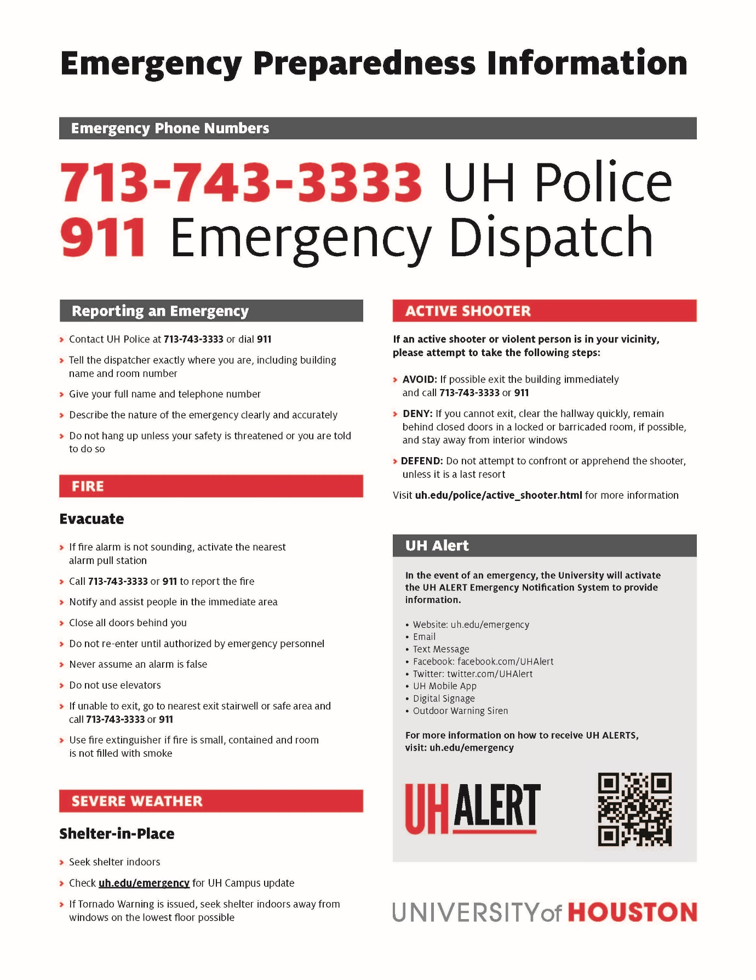 https://www.uh.edu/emergency-management/planning-and-response/building-department-preparedness/emergency-preparedness/

Attachment 9 – UH Police – Bomb Threat Checklist
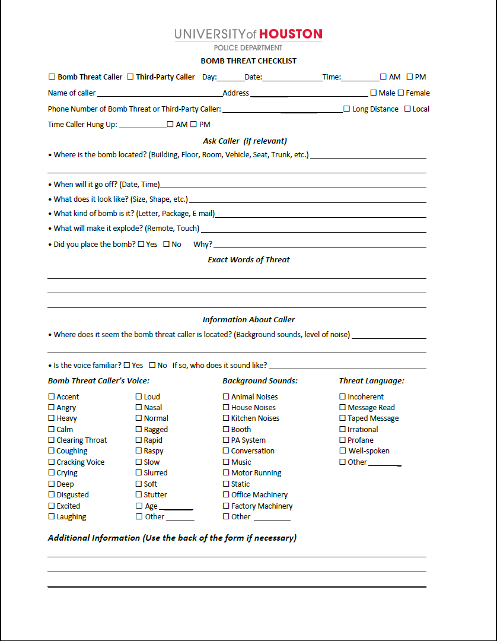
https://uh.edu/police/documents/uhpd-bomb-threat-checklist.pdf

Attachment 10 – UH Outdoor Warning Siren System Poster

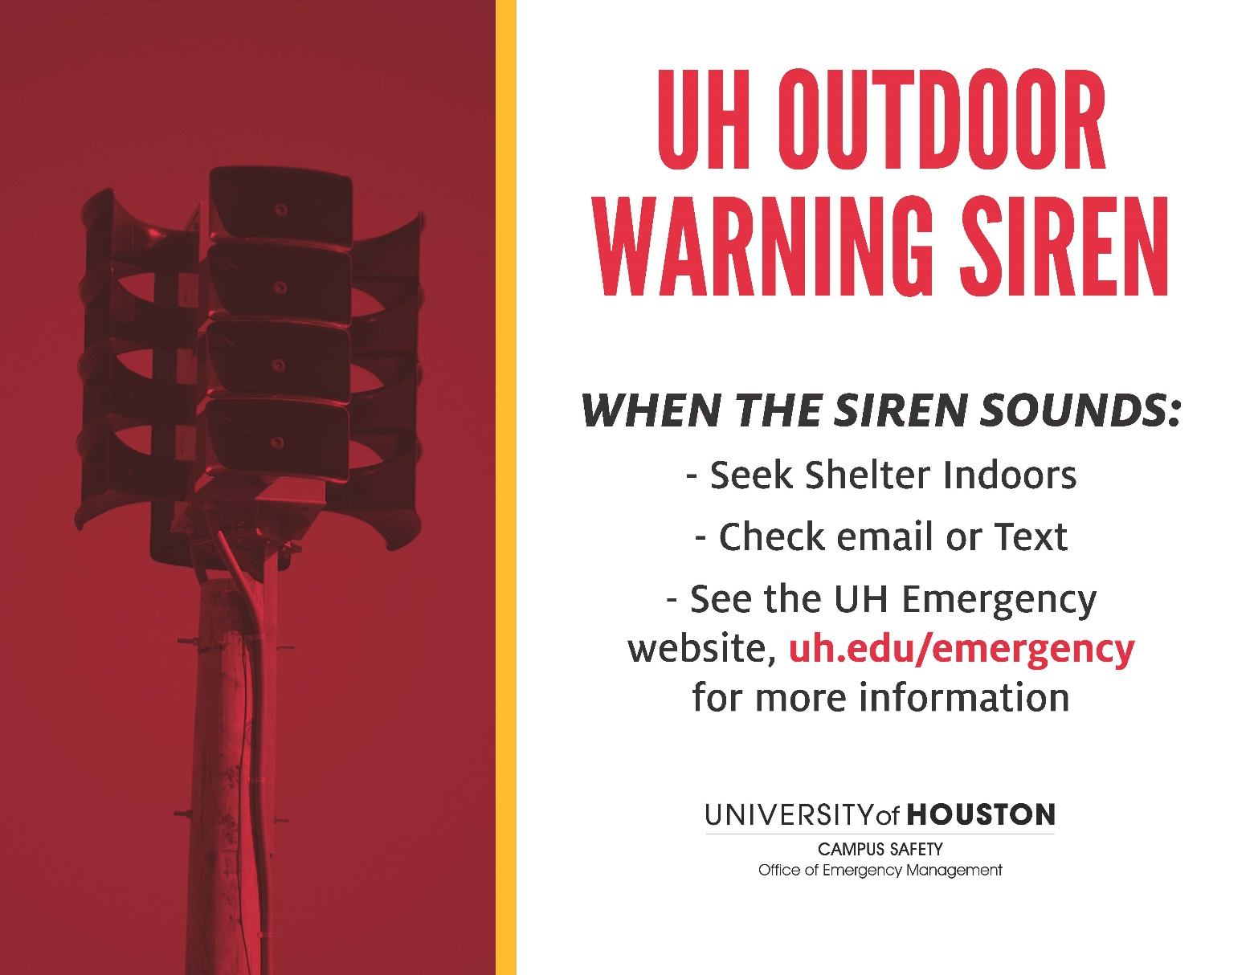

http://alerts.uh.edu/resources/siren/siren-warning-poster-approved-8-3-17-2.pdf

Attachment 11 – NIMS/ICS Training

IS -100.HE: An Introduction to ICS or IS100.b: Introduction to Incident Command System
http://www.training.fema.gov/EMIWeb/IS/courseOverview.aspx?code=IS-100.HE
http://www.training.fema.gov/EMIWeb/IS/courseOverview.aspx?code=IS-100.b

IS-700: NIMS, An Introduction
http://www.training.fema.gov/EMIWeb/IS/courseOverview.aspx?code=IS-700.a

IS- 200: ICS for Single Resources and Initial Action Incidents
http://www.training.fema.gov/EMIWeb/IS/courseOverview.aspx?code=IS-200.b

IS-800.B: National Response Framework, An Introduction
http://www.training.fema.gov/EMIWeb/IS/courseOverview.aspx?code=IS-800.b

ICS-300: Intermediate ICS for Expanding Incidents
ICS-400: Advanced Incident Command
Search for these courses here: https://www.preparingtexas.org/index.aspx

Additional course opportunities:
https://www.preparingtexas.org/index.aspx

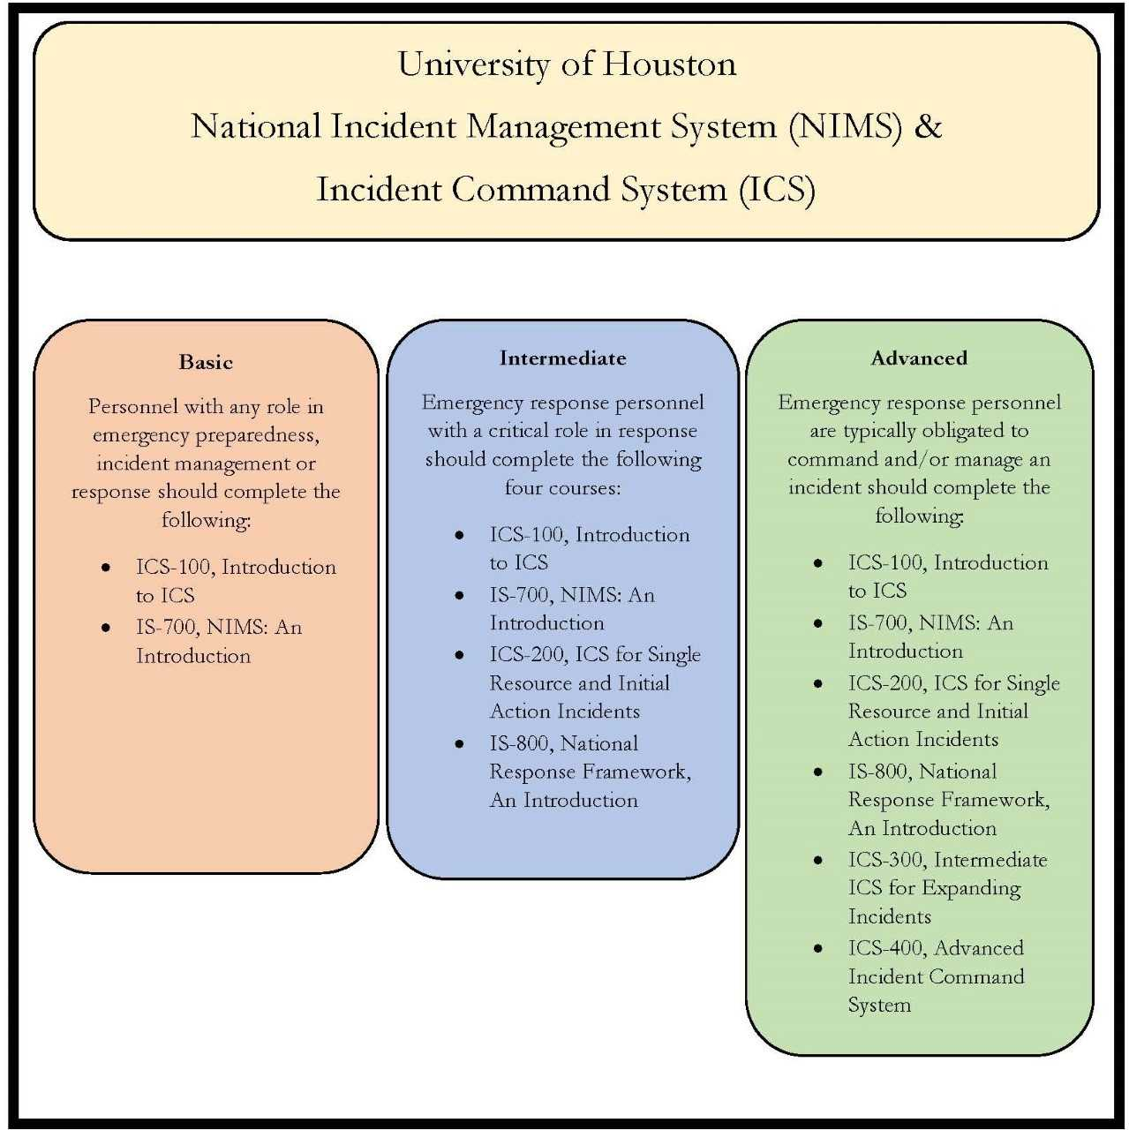
https://uh.edu/emergency-management/training-and-outreach/nims/nims_ics-training.jpg

Attachment 12 – UH CERT Training
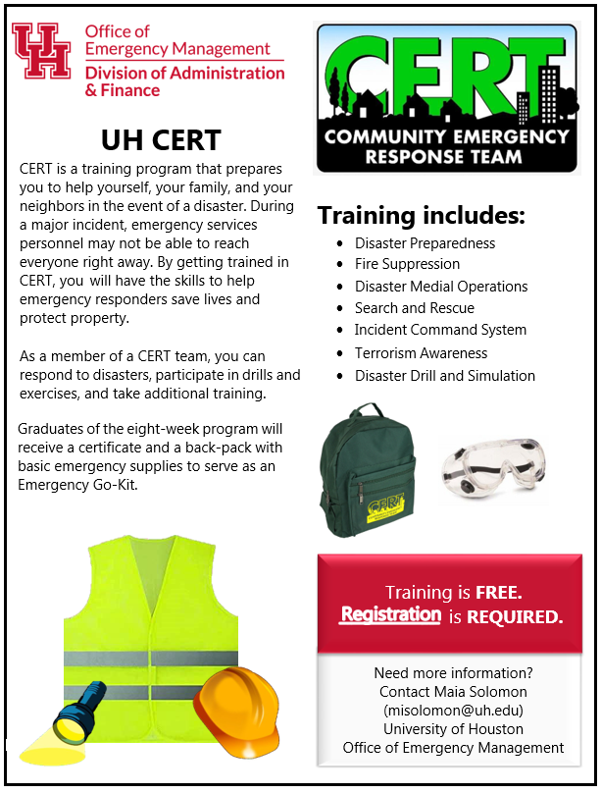
https://uh.edu/emergency-management/training-and-outreach/cert/

