SECTION 27 0553 - IDENTIFICATION FOR COMMUNICATIONS SYSTEMS
Revise this Section by deleting and inserting text to meet Project-specific requirements.
Maintain Section format, including the UH Master spec designation and version date in bold in the center columns in the header and footer. Complete the header and footer with Project information
Designer is required to adhere to the University’s “Network Infrastructure Design Standards,” “UH System IT Facilities: Baseline Standards,” and “Electronic Access Control Design Guide” available in Owner’s Design Guidelines on the University’s Facilities Planning and Construction web site.
This Section uses the term "Architect" or “Engineer.” Change this term to match that used to identify the design professional as defined in the General and Supplementary Conditions.
Verify that Section titles referenced in this Section are correct for this Project's Specifications; Section titles may have changed.
Delete hidden text after this Section has been edited for the Project.
- GENERAL
      - RELATED DOCUMENTS
        - Drawings and general provisions of the Contract, including General and Supplementary Conditions and Division 1 Specification Sections, apply to work of this Section.
        - The Contractor's attention is specifically directed, but not limited, to the following documents for additional requirements:
          - The current version of the Uniform General Conditions for Construction Contracts, State of Texas available on the web site of the Texas Facilities Commission.
          - The University of Houston’s Supplemental General Conditions and Special Conditions for Construction.
      - SUMMARY
        - Section includes:
          - Documentation practices and requirements for Communications Systems.
          - Required submittals.
          - Approved manufacturers and parts.
          - Detailed label requirements with examples.
        - This Section defines the requirements for labeling telecommunications infrastructure as described on the Drawings and/or required by these Specifications.
      - SUBMITTAL ADMINISTRATIVE REQUIREMENTS
        - Follow the Submittal Administrative Requirements as stated in Section 01 3300 “Submittal Procedures.” Use electronic format only.
      - ACTION SUBMITTALS
        - Product Data: For each type of product.
        - Samples: For each type of label and sign to illustrate composition, size, colors, lettering style, mounting provisions, and graphic features of identification products.
        - Identification Schedule:
          - Outlets: Scaled drawings indicating location and proposed designation.
          - Backbone Cabling: Riser diagram showing each Network Facility, backbone cable, and proposed backbone cable designation.
          - Racks: Scaled drawings indicating location and proposed designation.
        - Patch Panels: Enlarged scaled drawings showing rack row, number, and proposed designations.
        - Maintain telecommunications infrastructure records in a computer spreadsheet or database. PDF is not acceptable. Prepare a record for each backbone cable. The record shall show the cable name and describe the origin point and destination point of each cable. The cable record shall record what services and/or connections are assigned to each cable pair or strand.
      - INFORMATIONAL SUBMITTALS - Not Used
      - QUALITY ASSURANCE
        - Identification and administration work described in this Section shall comply with requirements outlined in Section 27 0500 “Communications General Provisions.”
      - TELECOMMUNICATIONS ADMINISTRATION
        - Owner maintains a system for documenting and administering telecommunications infrastructure.
        - Owner maintains a campus-wide labeling scheme for voice and data outlets and patch panels.
- PRODUCTS
      - PARTS AND MANUFACTURERS
        - Refer to Section 01 2500 “Substitution Procedures” for variations from approved manufacturers or parts. Obtain written approval for substitutions from both the Owner’s Project Manager and the UIT Project Manager.
        - Network Facility Copper, Fiber, and Coax Backbone Cable Labels
          - Panduit #LS7-75NL-1
          - Brady #WML-1231-292
        - Network Facility Copper, Fiber, and Coax Horizontal Cable Labels
          - Panduit #LS7-75NL-1
          - Brady #WML-317-292
        - Work Area Copper, Fiber, and Coax Riser Cable Labels
          - Panduit #LS7-75NL-1
          - Brady #WML-317-292
        - Patch Panel Labels
          - Panduit #LS7-38-1
          - Brady #CL-111-619
          - P Touch TZe-231
- EXECUTION
      - LABEL CHARACTERISTICS, STANDARDS AND CONVENTIONS
        - Labels shall meet the legibility, defacement, exposure and adhesion requirements of UL 969 Standard for Marking and Labeling Systems.
        - The labeling scheme shall meet or exceed the requirements of ANSI/TIA-606-C.
        - Label materials shall meet all applicable fire codes.
        - Labels shall be resistant to environmental factors (such as moisture, heat and ultraviolet light) and have a life span equal to or greater than that of the labeled item.
        - All labels shall be preprinted or generated by a computer or mechanical device. Handwritten labels are not acceptable, except as described in the instructions for labeling faceplates.
      - LABELING PROCEDURES
        - To be consistent with applicable standards and industry practices, labeling and color coding shall be applied to all telecommunications infrastructure components. A label shall carry a unique identifier that denotes a specific component. Color coding shall allow personnel to quickly identify how the component is used in the overall telecommunications infrastructure of the facility. Infrastructure to be labeled includes:
          - Copper and fiber optic outside plant cable, risers, horizontal (station) and patch cables.
          - Racks, cabinets and patch panels.
        - Visibility and durability
          - Select size, color and contrast of all labels to ensure that identifiers are easily read.
          - Labels shall be visible during installation and normal maintenance of the infrastructure.
          - Where insert-type labels are used, provide a clear plastic cover over the label.
          - For labels applied directly to a cable, apply a clear vinyl wrapping over the label and around the cable to permanently affix the label.
      - LABEL INFORMATION CONTENT
        - Fiber Optic Cable: Outside Plant (OSP)
          - At each end
            - Far-end building number and name (or standard abbreviation, if insufficient space, plus room number
            - Single-mode or Multi-mode
            - Strand count
          - At points where cable enters/exits tunnel or conduit (place label within 12 – 36 inches of tunnel or conduit, or nearest point that is clearly visible)
            - Building number and name at both ends (with the network uplink end first), plus room number
            - Strand count
          - Along the length at 100-foot intervals, or nearest point that is clearly visible
            - Building number and name at both ends (with the network uplink end first), plus room number
            - Strand count
        - Fiber Optic Termination Panels: OSP
          - At each end
            - Far-end building number and name, plus room number
            - Single-mode or Multi-mode
            - Strand count
          - Additional instructions
            - Use both machine-printed labels AND manufacturer’s color coding on ferrules to denote single-mode fiber or multimode fiber
              - Yellow = Single-mode
              - Orange = Multi-mode
            - On each separate 6 or 12-strand panel insert, place a factory label with the panel number
            - On each strand’s termination, place a factory label, or installer-applied machine-printed label with the strand number for that cable.
            - If there is a factory supplied label for the door or cover, use it to record cable numbers and strand number.
        - Fiber Optic Cable: Risers
          - At each end (Entrance Facility and its interconnecting equipment or Floor Distributor (FD)
            - Far-end Entrance Facility, equipment or FD room number
            - Single-mode or Multi-mode
            - Strand count
        - Fiber Optic Termination Panels: Risers
          - At each end
            - Far-end Entrance Facility, equipment or FD room number
            - Single-mode or Multi-mode
            - Strand count
          - Additional instructions
            - On each separate 6- or 12-strand panel insert, place a factory label with the panel number
            - On each strand’s termination, place a factory label or installer-applied machine-printed label with the strand number for that cable

        - Horizontal (Station) Cable - Fiber Optic or Copper
          - At each end (behind the faceplate and on the patch panel)
            - Far-end equipment or FD room number
            - Cable number (shall match the number on the patch panel and faceplate)
          - On the faceplate
            - Mark with an ultra-fine tip, black, permanent Sharpie®, then cover with a machine printed label
            - Room number: upper left corner of the plate
            - Cable number: directly below (preferred) or next to the jack
            - If fiber optic, also specify Single-mode or Multi-mode
          - At the equipment or FD patch panel
            - Cable number
            - Room number: below the cable number

        - Patch Cables - Fiber Optic or Copper
          - At each end
            - Source and destination
        - Wireless Access Points (WAPs) and Associated Jacks

          - WAP labeling has two parts:
            - UH WLAN support sticker, provided by UIT,
              - mounted parallel to the silver HPE Aruba logo on the front of the WAP.
            - Cable information label
              - Label each WAP in a visible area on the device, to be readable from the ground with no magnification
              - BD/FD room number
              - MAC address (last 6 digits)
              - Jack panel letter and number for both runs
              - Example for an AP with a mac of 54:D7:E3:C6:75:31 that runs back to FD 123 and terminates on panel I jack 39/40. Label should read: FD123-I39, 40-C6:75:31.
              - This label should be placed parallel to the HPE Aruba logo and the UIT support sticker.

          - In the network facility, the jack labeling has two parts:
            - Room number where the cable runs to. If the cables terminates in room 353, then the label would be RM 353. If the cable terminates in a hallway, then the room number will be closest room, room 344, with the designation HW for hallway.
            - Jack panel letter and jack number

          - Example of AP and Jack labeling:
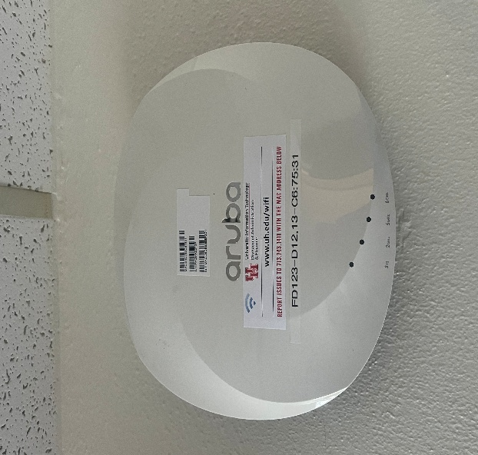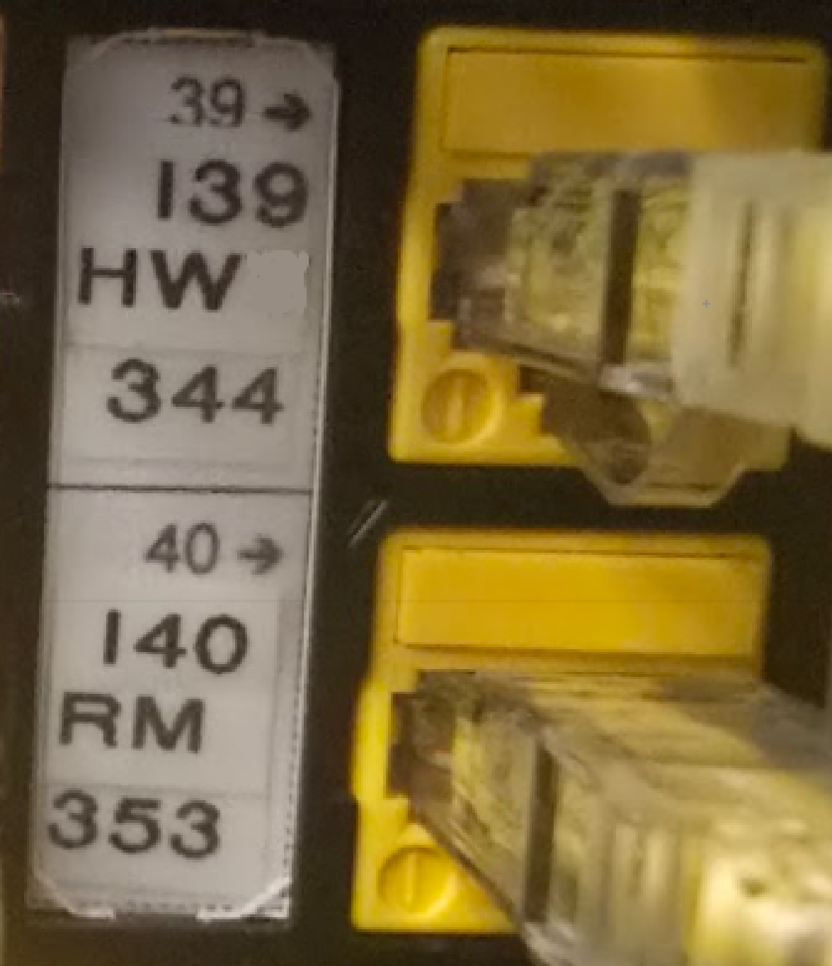

        - Cameras
          - To be labeled with these elements, separated by hyphens:
            - FD number
            - Patch panel id
            - Number of the nearest room/door
            - Camera number
            - EXAMPLE: NF-109-B19-113-C106

          - Onscreen labeling
            - Room name and/or number or object viewed (shall match camera schedule and schematics)

        - Circuit Breaker Panels and Electrical Outlets
          - All telecommunications circuits are to be clearly labeled on circuit breaker panels and the circuit id number to be on the face plate of the outlet in the NFs.
      - EXAMPLES
        - Fiber Labeling (see Fiber Labeling Illustration and example, below)
          - There shall be three areas labeled on each fiber panel:
            - Above the individual columns on label panel
            - Above the letters on each column
              - First line: Destination building number - Destination NF room number
              - Second line: Destination fiber distribution cabinet - fiber type
          - On each line in each column, individual labels for each fiber port
            - Destination panel - Destination fiber port - Destination color
Fiber Labeling Illustration
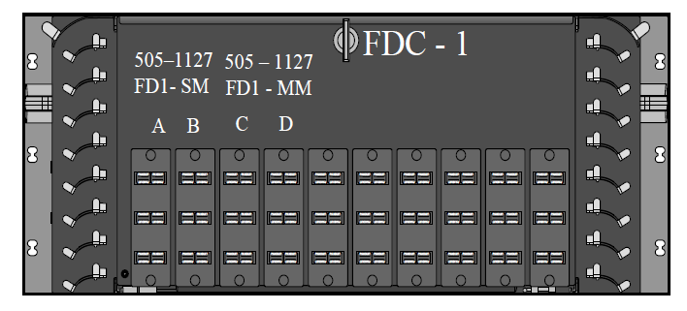

Typical Fiber Colors and Pair Designation
Blue: Bl | Orange: O | Red: R | Black: B
Green: G | Brown: Br | Yellow: Y | Violet: V
Slate: S | White: W | Cyan: C | Rose: Ro

Fiber Labeling Example

505-1127 | Label the front of each fiber optic distribution box with FD-sequence number.  EXAMPLE: FD1
A
A1-Bl
A2-O
A3-G

        - Copper Labeling (see Copper Labeling Illustration, below)
          - Each patch panel shall have an alphanumeric designation
          - Jack: each jack number on the patch panel shall be determined by room number along with the panel and port designation as shown.

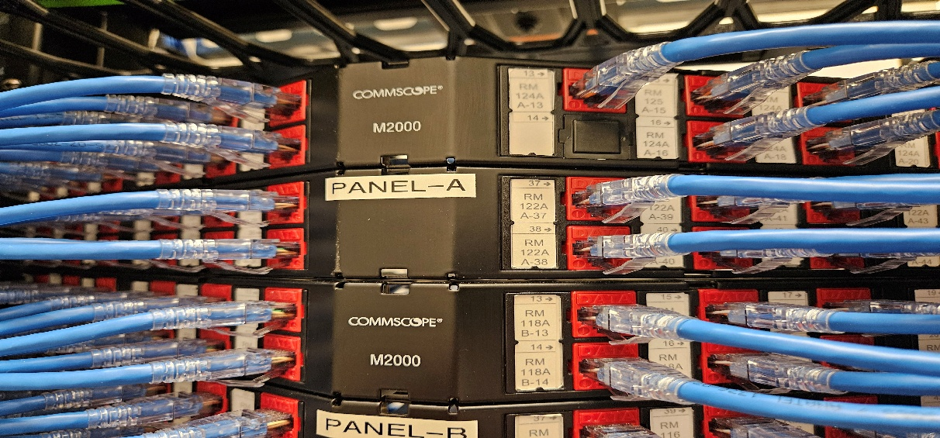

        - Copper Patch Panels (Category Cabling)
          - UIT to furnish requirements
        - Office Faceplates (see Office Faceplate Labeling Illustration, below)
          - First line: NF room number and the room number of the communications outlet
          - Second line: first jack number followed by the panel letter followed by the second jack number
Office Faceplate Labeling Illustration
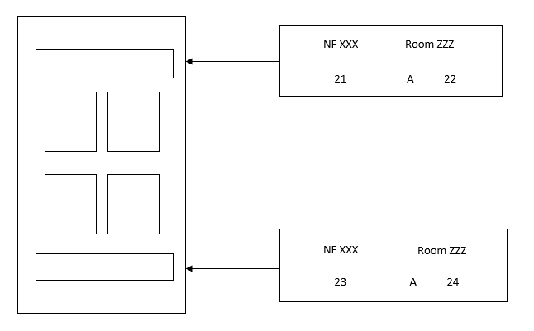

        - Patch Cords
          - Panel number — Jack number — Switch number — Port number
          - Label each end of the cable
Patch Cord Example
A23-SW1- P11-17

        - Racks
          - Label the top of each rack with the rack number
Rack Example
Rack 1

      - PROJECT CLOSE-OUT
        - As-Built Drawings
          - Provide a complete and accurate set of As-Built Drawings in .dwg, .rvt and .pdf formats.
          - In the As-Built Drawings, record the identifiers for major infrastructure components including the pathways, spaces and wiring portions of the infrastructure. Provide separate drawings if warranted by the complexity of the installation or scale of the Drawings.
END OF SECTION 27 0553

