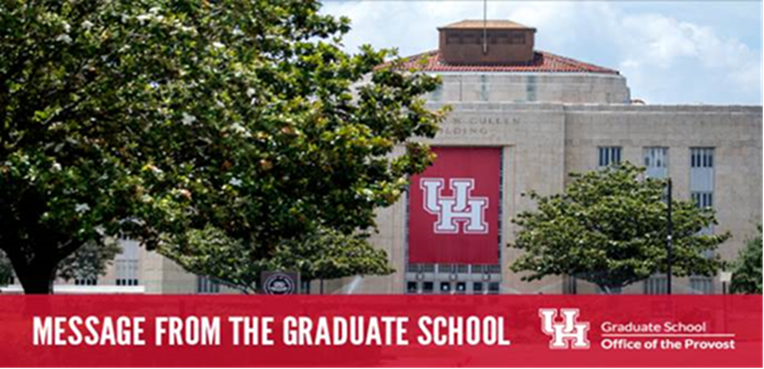

**September 16, 2024**

**This weekly newsletter from the UH Graduate School contains important information for graduate and professional students. Each week, new items are in red.**

**Graduate Student Welcome: Remix Edition**

Thank you to everyone who joined us for the Graduate Student Welcome event at Bates Law! Your enthusiasm was incredible, and we’re thrilled by the turnout. We apologize for running out so quickly, but we’ve got great news! We’re hosting another event to distribute lunch boxes, with priority given to those who missed out on September 5th.

**Date/Time:** October 3, 11:00 am – 1:00 pm  
**Location:** Bates Law, Ground level

Don’t miss out— **Register** [**HERE**](https://universityofhouston.iad1.qualtrics.com/jfe/form/SV_a3E4A251B96WLem) **for your box lunch.** Registration is open until September 25th and is capped at 400, so secure your spot today! We can’t wait to see you there!

**Grad(graduate) Student Group (from CAPS)**

The Grad group is a process-oriented group with a focus on helping graduate students process their unique and collective experiences. This group is a good fit for those who struggle with interpersonal concerns, isolation, anxiety, or feelings of being overwhelmed due to the rigor of graduate academics and obligations. Individuals who participant in this group can expect to be engaged in open dialogue that serves to connect, increase understanding, and self-awareness. This group does not have a specific topic of discussion. Thus, the participants are encouraged to honor their goals and to highlight the important aspects of their graduate journey. **Criteria:** Currently enrolled UH graduate student.    **To be held weekly on Thursdays from 5-6:30 pm at CAPS Health 2 location.** Students must attend an Access Visit to sign up for this group.  For more information: <https://www.uh.edu/caps/services/access-visit/>

**Getting Started: Preparing a Competitive Graduate Fellowship Application**   
This virtual workshop will guide you through the process of finding and preparing graduate fellowship applications. The workshop will also provide tips for preparing competitive Cullen Travel Fellowship application.   The workshop will be divided into three parts: 1) Finding and Applying for Funding, 2) Developing your Application and 3) Letters of Recommendation. Register [**link**](https://universityofhouston.iad1.qualtrics.com/jfe/form/SV_07Z8DMoYpgTL0Oi).  
**Date/Time:**Tuesday, Sept. 17, 2-3:15 pm via zoom

**Humana Research/Graduate School Networking Event (Act now, registration closes Sept. 18)**

Th Humana Institute and the Graduate School are co-hosting a research mixer for graduate students. Experience a night of learning, discussion and connection:

* Screening of Heroin(e), an Academy Award-nominated documentary about the opioid pandemic.
* Participate in a panel with experts to explore the film’s themes and ask questions.
* Enjoy delicious food and refreshments throughout the event.

Connect with fellow graduate and professional students from various disciplines in a relaxed setting. Register [**here**](https://universityofhouston.iad1.qualtrics.com/jfe/form/SV_57M2dmUgldwB2Vo) by September 18, 2024.

**Date/Time: October 2, 6pm-8pm**

**Location: Room 237, Student Center**

**Participation is limited to the first 50 registrants.**

For more information, contact [humana-institute@uh.edu](mailto:humana-institute@uh.edu).

**3MT Info Session: Getting Started with your 3MT Presentation (Virtual Info Session):**The UH Graduate School will hold an info session for the [UH 2024 3-Minute Thesis or 3MT competition](https://uh.edu/graduate-school/events/research-day/). In a 3MT competition, graduate students explain their research to a non-specialist audience in just three minutes. Besides the time limitation, students are also limited to a single static PowerPoint slide with no additional electronic media or props.All 3MT finalists receive a scholarship award!Register [here](https://universityofhouston.iad1.qualtrics.com/jfe/form/SV_cOPHeGaUGkEMqcm) to learn more.  The session will be recorded and all registrants will receive a link to access the presentation.

**Date/time:** Thursday, October 3, 12-1:15 pm

**Quick links to resources:**

[**Coogs Care**](https://uh.edu/coogs-care/)

[Cougar Cupboard](https://uh.edu/dsaes/cougarcupboard/)

[**Counseling and Psychological Services (CAPS)**](https://www.uh.edu/caps/)

[University Career Services](https://uh.edu/ucs/)

[Graduate Student Ombuds](https://www.uh.edu/graduate-school/ombuds-services/)

Go COOGS!