UH Rocks!
  - A Virtual Field Trip of UH Campus Building Stones
  - Physical Geology – Spring 2026
Name:
myUH ID number:
Professor and/or TA’s Name:
Class and/or Lab Time:

Academic Honesty (Acknowledgement Required)
The UH Rocks! virtual field trip is to be completed by yourself; you should not work with a partner or group. Do not search for answers online because 1) it is cheating, 2) the posted answers are incorrect, and 3) questions change every semester. It is a violation of both the UH Academic Honesty Policy to upload any of this material to sites such as Chegg and CourseHero If you are unfamiliar with a word or geologic concept, it is okay to find the correct spelling and definition. If you need help, go to the Geoscience Learning Center.
By submitting this work, I, Type Your Name Here attest that I have not violated the UH Academic Honesty code. I completed this assignment by myself, wrote the answers myself, and did not copy any portion of my answers from another student, website, or any other source, including AI such as ChatGPT, Microsoft CoPilot, Google Gemini, or Anthropic.

Instructions
The buildings, boulders, and sculptures on the University of Houston campus use many geologic materials. This tour takes you to many places on campus to learn about them. At each stop, you will need to read about the rocks, look at images, and answer questions.
Each location has a short description of the stone and several photos. There are links to 3D montages created from photos and LiDAR data. Be sure to click both the photos and the link to the 3D images to see details of the building stones. The process of combining 2D images to create these 3D images isn’t perfect, so some of the 3D images have gaps and irregular edges.

Accessing the Trip
This virtual field trip was built in Google Earth. Click here to access the trip. The first page that comes up is a summary of building stones. Use the menu on the bottom left to move between stops. At each location, a box with information about each stop and images will appear on the right side of the screen. Click the pictures to enlarge them.

Written Answers
All answers should be written in complete sentences and typed in the supplied boxes. Your responses will appear in a green-colored, bold font, do not change this. Any answers not written in full sentences will be marked as incorrect and will not receive credit.
Each stop has several questions. Look at the instructions to see how many questions you must answer per stop. You can choose which of the available questions you want to answer. You should have answers for 18 questions for your submission.

Assignment Submission
Save your completed Word document as “yourlastname_firstname_UHRocksVFT”. Failure to use this naming convention may result in you not receiving credit. The file size must be less than 100 MB. If you need to reduce your file size, make sure images/annotations are still legible. Only Microsoft Word and PDF formats are accepted.
Due Date: Friday, May 1, 2026
Submission link: Submit your file via Microsoft Forms. You must be logged into your @cougarnet.uh.edu account. Make a separate submission for each VFT you complete.
Teaching Assistants will begin grading submissions after the deadline. After your work is graded, you will receive a confirmation email from a TA. Submissions are graded as pass/fail. If your assignment requires resubmission because of too many incorrect questions, missing answers, or incomplete sentences, you will have 48 hours to do so.

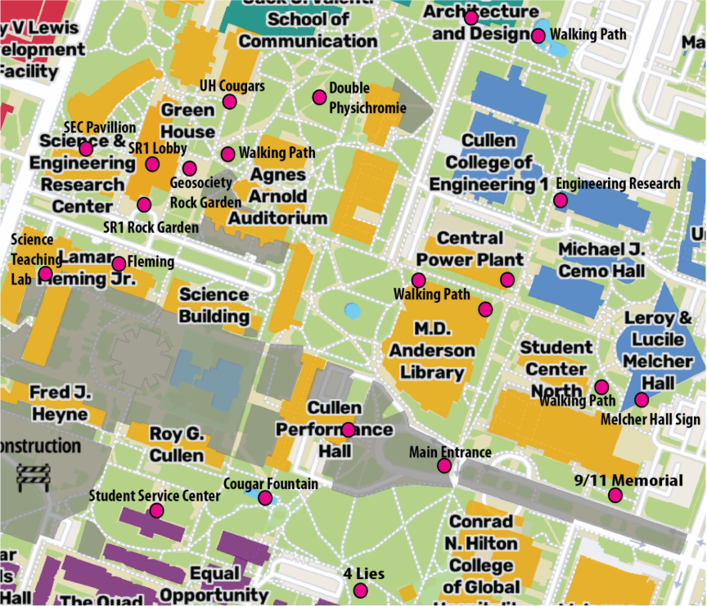
2026 UH Campus Map showing stop locations (pink dots) as well as others with interesting rocks. Gray areas are under construction. So, if you want to see these rocks in person, some of the stops on this virtual trip may not be accessible during construction.

Introduction Slide
Be sure to read the introduction to the Google Earth trip, it contains important information that can help you answer some questions. Access the trip here.

Stop 1 SR1 Lobby (Answer five of these questions for Stop 1)

Igneous Rock
- What is the extrusive equivalent of this rock?

- Where in Texas can you find a similar rock? Using your knowledge of igneous rocks and tectonic settings, why do you think it is rare in Texas?

Sedimentary Rock
- Why did the builder use travertine for the lobby walls?

- Look at the layers in the travertine. How do you think these form?

Metamorphic Rock
- Why is marble used for making sculptures and decorative stone? Remember the physical properties of minerals.

- Do you think this marble formed in regional or contact metamorphism? Remember that regional metamorphism is associated with deformation and contact metamorphism only involves changes in temperature.

Stop 2 SR1 Mineral Cases (Answer two of these four questions)
This summer, the mineral cases were updated. The changes are mostly cosmetic except we are about to add some UV fluorescent minerals to a case on the second floor.
- Which case is associated with Dr. Rosalie Maddocks? This year is her 60th year of teaching at UH!

- Jim Gibson lent over 200 mineral specimens. Most of them are prehnite. What color is this mineral, and where is it formed?

- What kind of dinosaur footprints are on display?

- In what class offered by the EAS department would you learn about fossils?

Stop 4 SR1 Rock Garden (Using the 3D image, answer one of these three questions)
- There are >5 igneous rocks here. Look at this link and describe this igneous rock. This rock was collected near Llano, TX. Zoom in and see the bluish-gray quartz. Is it intrusive or extrusive?
- There are >5 sedimentary rocks here. Many of these are chemical sedimentary rocks. Look at this link, describe its features, and decide what type of sedimentary rock this is.

- Use this link to see a 3D image from the rock garden. Is this a rock or mineral? How can you tell? You can learn more about this at https://mediaplayer.pearsoncmg.com/assets/SdjqjKsaSz8mbGcCz8TIGkHdiT6gxDVH

Stop 5 Fleming Ledge (Answer one of these three questions)
- What was the cooling rate for this granite?

- How old is this rock?

- What is the name for the black regions in this ledge? Did they form before or after the granite?

Stop 6 Fleming Limestone (Answer one of these three questions)
- When was this sedimentary rock deposited?

- What was the environment in which this sedimentary rock formed?

- Which fossils are common in this rock?

Stop 9 Cullen Hall Travertine (Answer one of these three questions)
- What type of rock is this?

- Was this rock deposited in the same orientation as it is in the lobby?

- Describe the differences and similarities between this rock and the walls of the SR1 lobby at Stop 1.

Stop 11 Student Service Center Ceiling (Answer one of these three questions)
- Are these stalagmites or stalactites? Why?

- Where would you go in Texas to find an example of a natural stalactite or stalagmite?

- How would you confirm that this is made of the mineral calcite?

Stop 11 Student Service Center Ledge (Answer one of these three questions)
- Although the minerals in slate are too small to be seen without a microscope, what platy minerals do you think are present?

- What type of rock was this before it was metamorphosed?

- Along what type of plate boundary would slate most likely form?

Stop 13 Statue of Four Lies (Answer one of these three questions)
- Watch a Youtube video by the two artists as they describe their thoughts about this statue. What would you do to dress up this sculpture?

- How many buildings on campus have you seen with this building stone? List them.

- What type of depositional environment does this limestone represent? What were the water conditions (i.e., temperature, depth, oxygen abundance, etc.) within which these ancient shelly organisms thrived?

Stop 14 Cullen Hall Serpentinite (Answer one of these three questions)
- How is rock formed?

- Describe the key characteristics of this rock? Look at the third picture. Do you think it looks like snake (serpent) skin?

- Have you ever been to a concert or lecture in the Cullen Hall performance center? If so, which concert/lecture did you go to? Did you notice this rock as you went to your seat?

Stop 19 Granitic Gneiss and Aplite (Answer one of these three questions)
- Describe the gneiss. Use full sentences.

- Describe the felsic dike. Use full sentences.

- During the 200 million years between metamorphism and intrusion of the dike, what happened to gneiss?

Stop 21 Benches at School of Architecture (Answer one of these three questions)
- Why did the sculptor choose this granite instead of granite found near Fleming?

- Have you tried sitting on these artistic benches? If so, describe your reaction to this artwork.

- Do you have a favorite song or artwork similar to this stone bench? Why?

Assignment Submission
Save your completed Word document as “yourlastname_firstname_UHRocksVFT”. Failure to use this naming convention may result in you not receiving credit. The file size must be less than 100 MB. If you need to reduce your file size, make sure images/annotations are still legible. Only Microsoft Word and PDF formats are accepted.
Due Date: Friday, May 1, 2026
Submission link: Submit your file via Microsoft Forms. You must be logged into your @cougarnet.uh.edu account. Make a separate submission for each VFT you complete.
Teaching Assistants will begin grading submissions after the deadline. After your work is graded, you will receive a confirmation email from a TA. Submissions are graded as pass/fail. If your assignment requires resubmission because of too many incorrect questions, missing answers, or incomplete sentences, you will have 48 hours to do so.

