Concur Log-in Updates (via computer)
Effective November 20th, the following steps are required to log into Concur.
- Log into Access UH, and select the Concur tile.
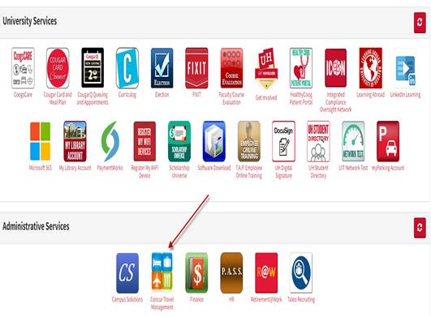
- You will be routed to the Concur website: www.concursolutions.com.
Enter your CougarNet e-mail address and click “Next”.
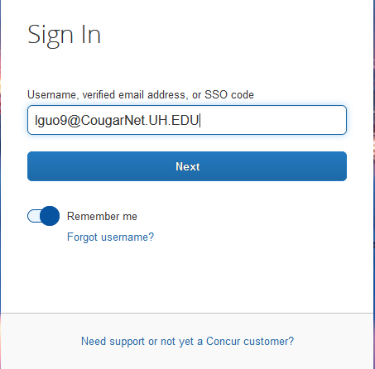

- Select “Sign in with UH CougarNet – IDP”.
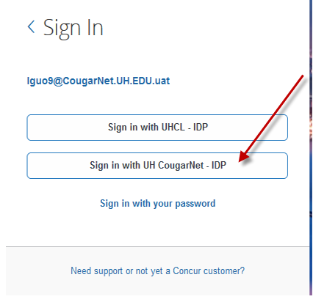
- Select your account.
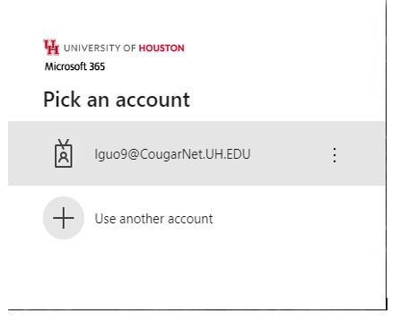
- Enter CougarNet password and click on “Sign in”.
