Concur Log-in Updates (via mobile app)
Effective November 20th, the following steps are required to log into Concur.
- Go to SAP Concur app home page and enter cougarnet e-mail address
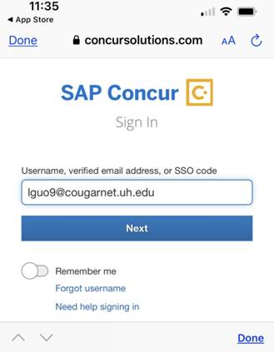
- Select “UH CougarNet – IDP”.

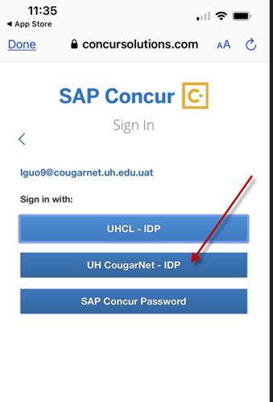
- Sign in with your CougarNet e-mail address and password.
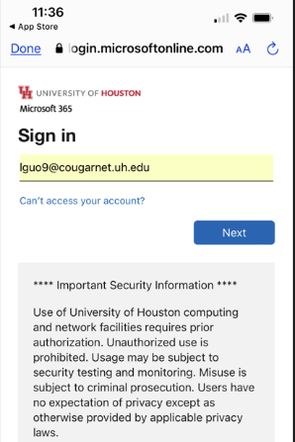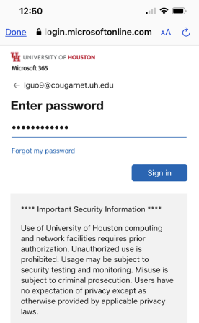
- The system will require the second factor authentication, select “Enter a Passcode”.
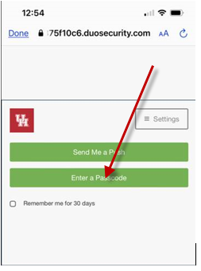
- Go to your “Duo” app, copy the passcode.
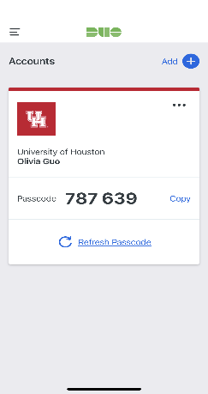
- Go back to Concur login page and paste the passcode, feel free to check “Remember me for 30 days”, and then click “Log in”
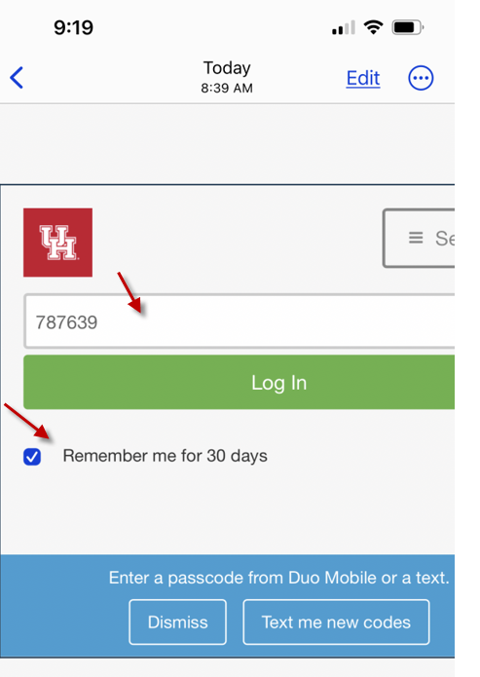
- You will be directed to SAP Concur app home page.
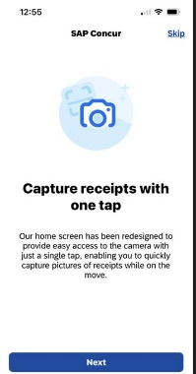

- The system will ask you to enable or cancel the Face ID function. Once you enable or cancel you will be logged in.
