How to Use State Contracted Rental Car Vendors

- Travelers are strongly encouraged to book a rental car from state-contracted vendors because the rate is fixed, and LDW (liability and loss/damage waiver) insurance is included in the base rate.
- Per MAPP 04.02.01B, if a non-contracted rental car vendor is used, the traveler should purchase liability insurance unless covered by their own car insurance, and the collision damage waiver for non-contracted rental cars.
- The university is contracted with Enterprise, Avis, and Hertz. Website information and directions on how to book with each are noted below:

Enterprise
https://etd.ehi.com

- If you are first time user, please reach out AP Travel Team ( if you are DBA or Business Contact of your department ) or your DBA ( if you are traveler ) so that you can be added as new user.
- After your name is added, you should receive an email from Enterprise
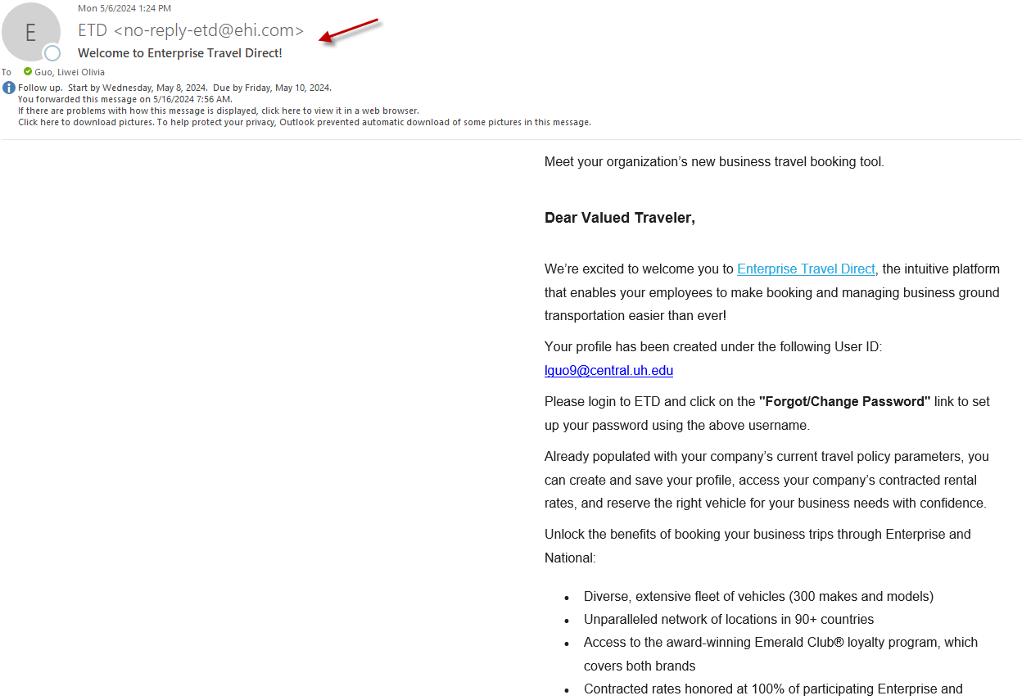
- Log in as instructed on the email, and you will see this webpage which is designed for UH only:
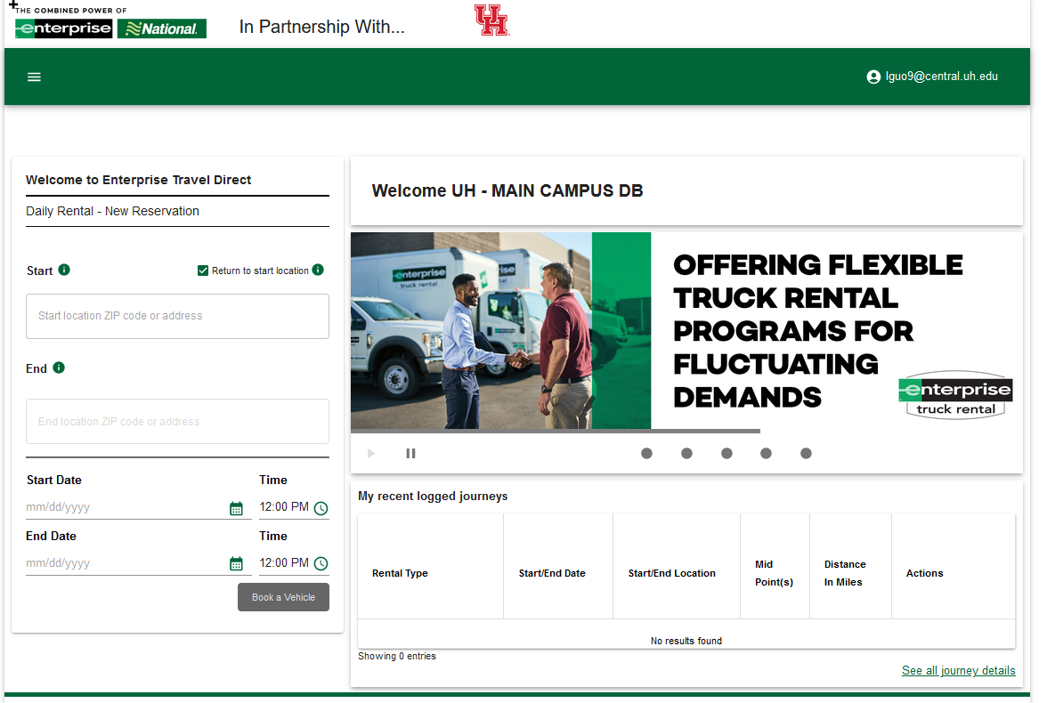
- Travelers, since you are granted company employee access, you will be able to make reservation for yourself from home page
- DBAs or Business Contacts, since you are granted company admin access, you will be able to make reservation for your department employees, guests, add travelers as company employee and pull invoices
a). Add new users:
Go to Home tab on the left top of the page and click “Manager Users”

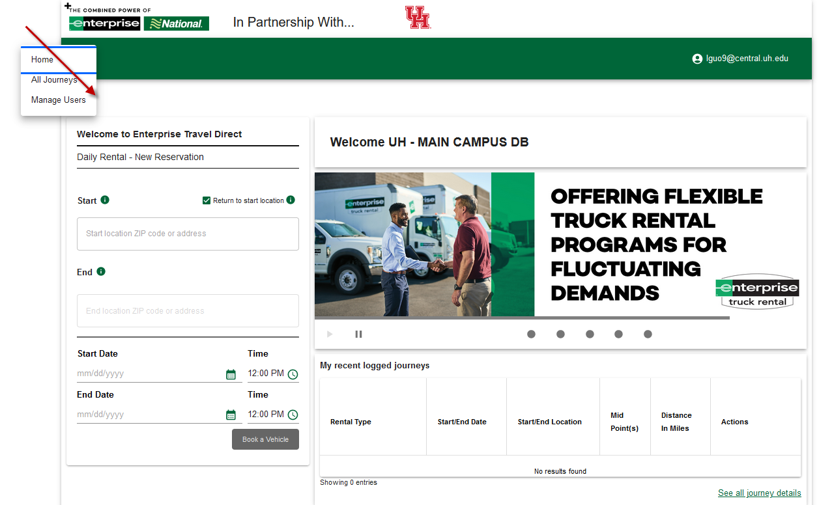

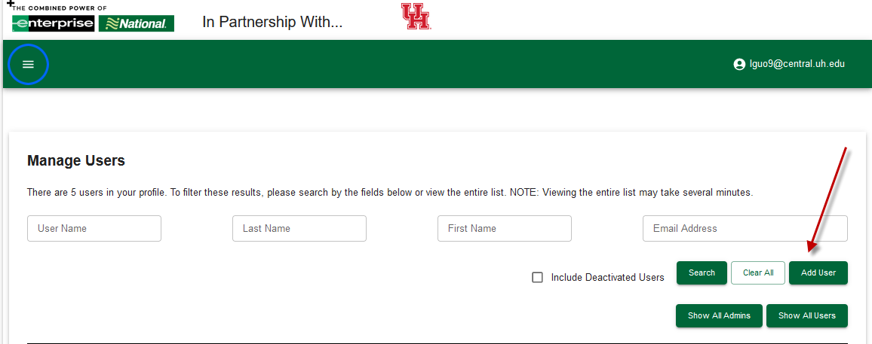
Fill out all the required information, user name should be the user’s cougarnet email address
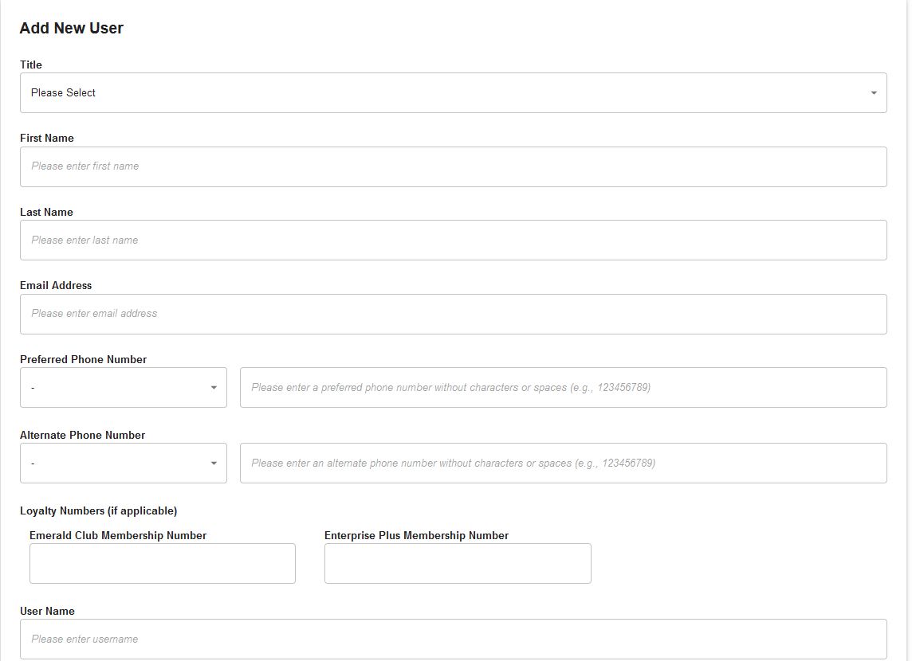
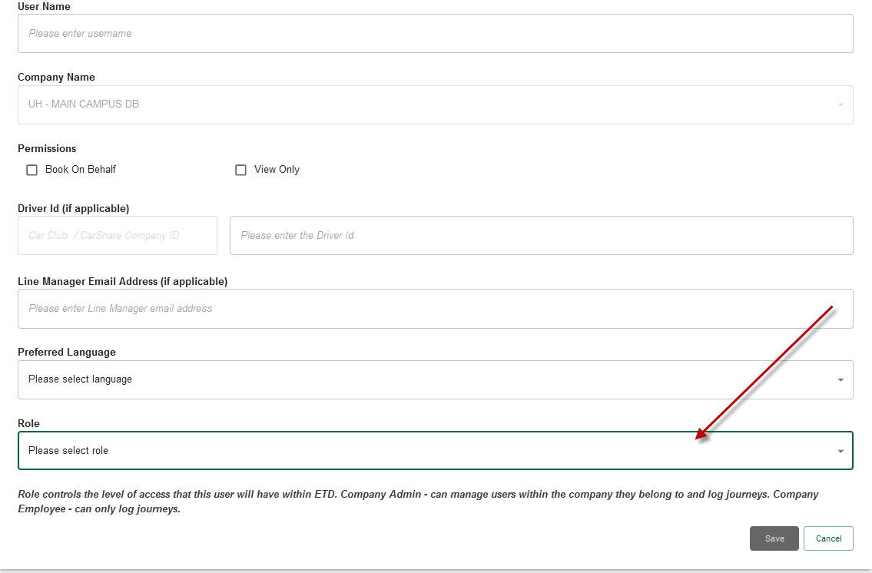
Make sure to select “Company Employee” role for travelers
b). Pull invoices
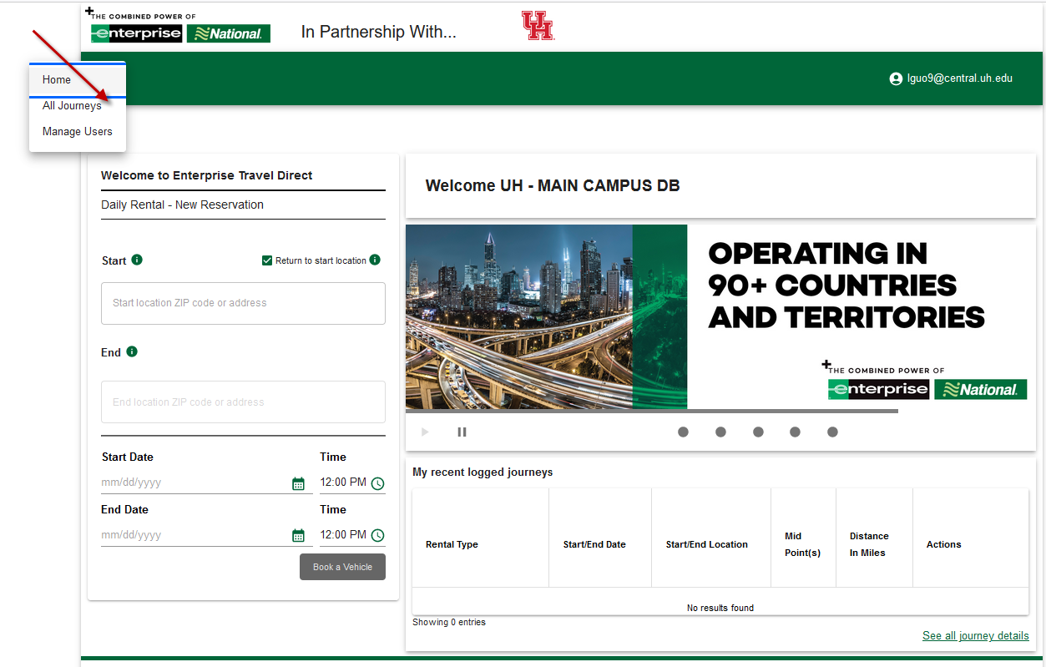
Click “All Journeys” and you will see all the reservation details
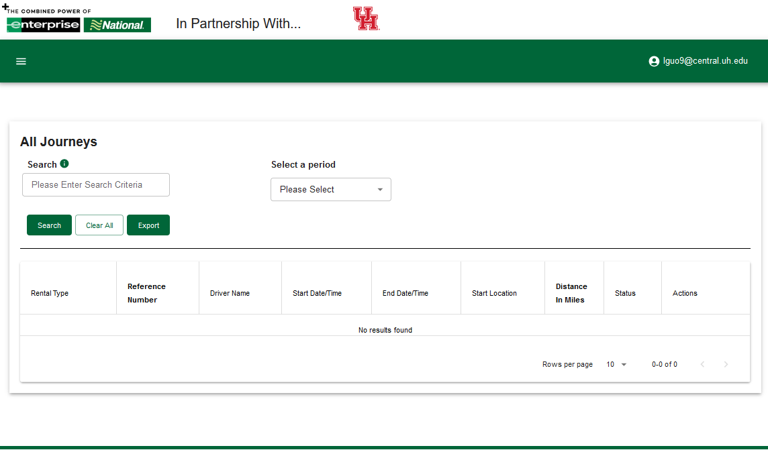

Hertz
https://www.hertz.com/
Go to the Hertz website, click “ Add a discount code.”
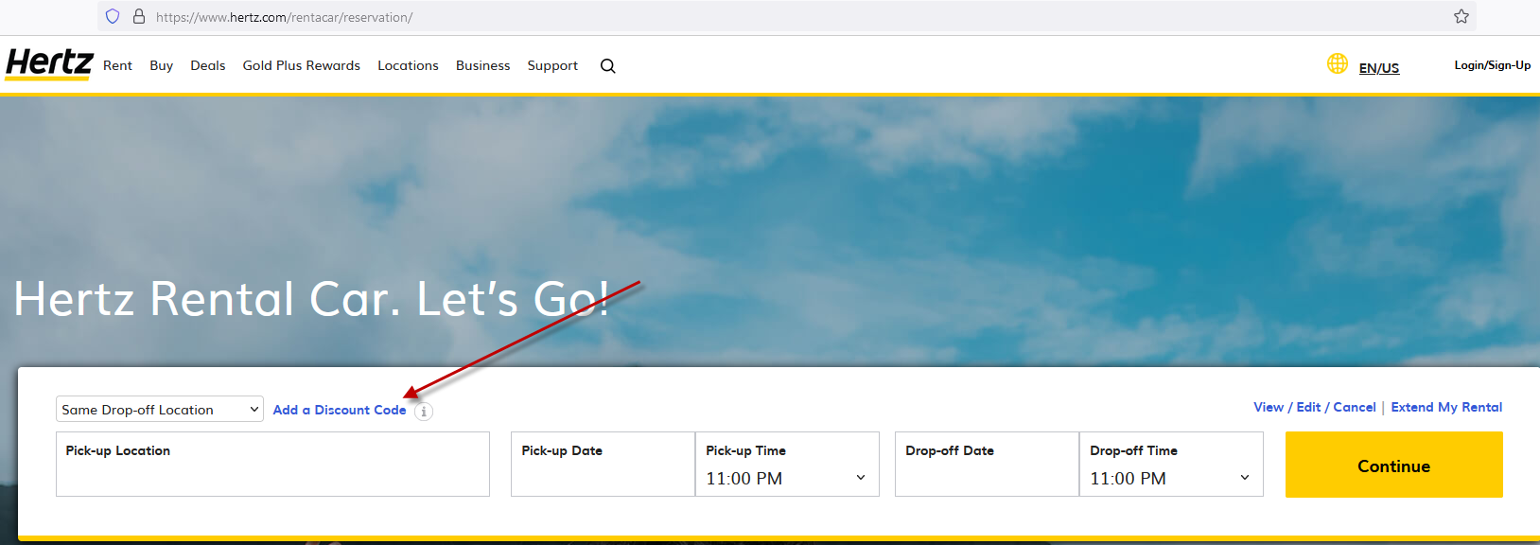

- Enter the verification code in “Discount. CDP/Club Code:”( Please contact AP Travel Group for this information.) Select business under “I am booking this trip for business” and Yes, under “Quote me the program my company has negotiated .” Then click “Apply.”
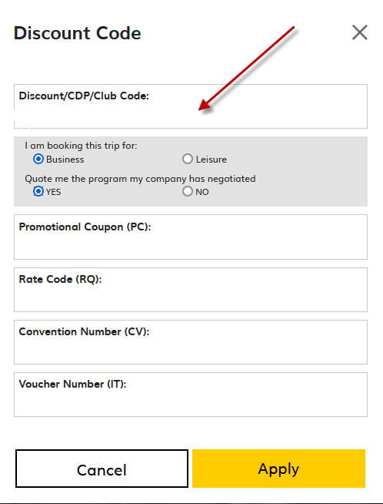

- Select the pick-up location and time and Drop-off location and time and click “Continue.”

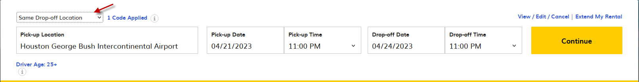
- Select the car. (Please make sure you are following UH policy.)
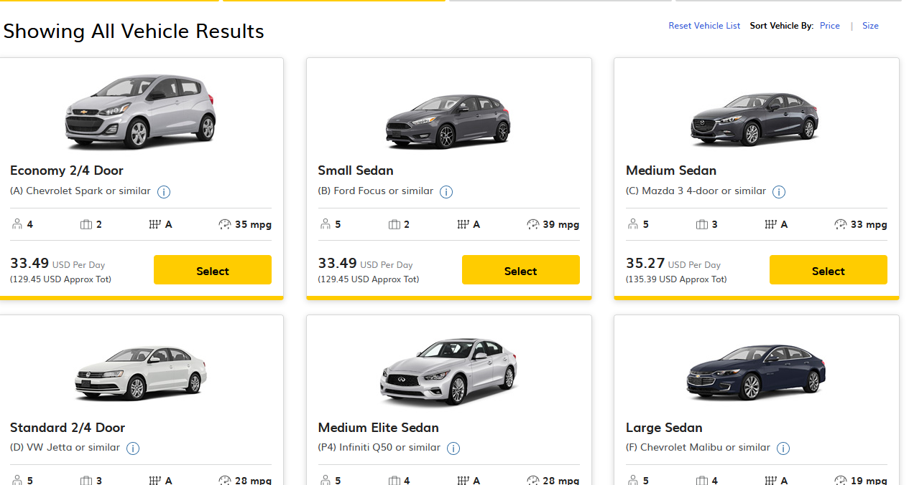

- DO NOT select any equipment on this page ( LDW is pre-selected). Click “Continue.”
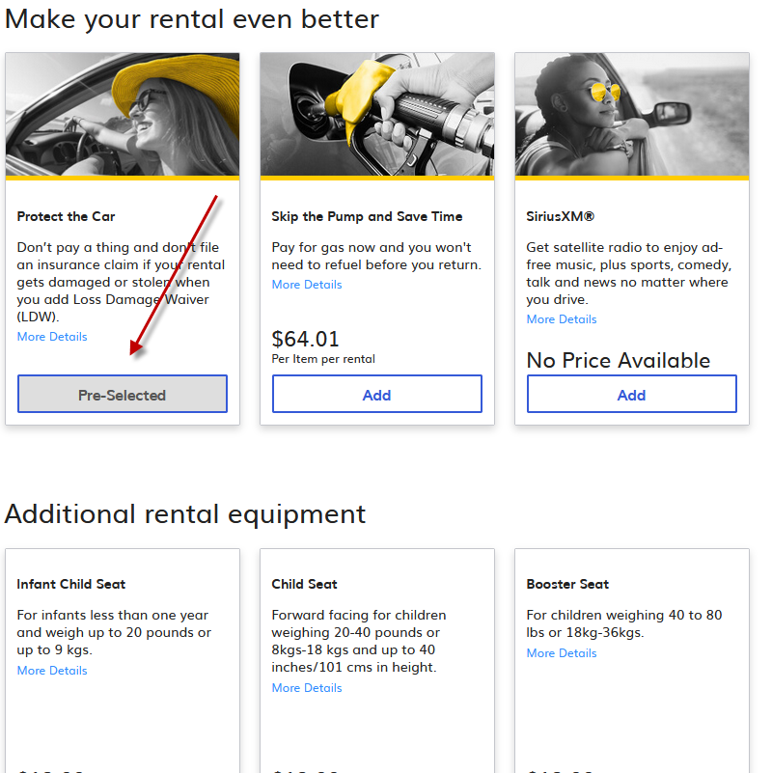
- Enter Driver information and then “Submit.”
