How To Do Price Comparison --- Rental Car vs. Personal Car Mileage (State Fund Only)

Per Texas Comptroller Office policy, for all travel paid or reimbursed with state-appropriated funds, traveler must compare the cost of using a personal vehicle versus renting a vehicle using the Texas Comptroller’s website (https://fmx.cpa.texas.gov/fmx/travel/mileage/).
A screenshot of the completed comparison must be attached to the Travel Request. The traveler must select the most cost-effective option based on the results.

- Go to Comptroller Office website: https://fmx.cpa.texas.gov/fmx/travel/mileage/

- Enter all the required information based on the destination (In-State or Out of State) and click “Submit”
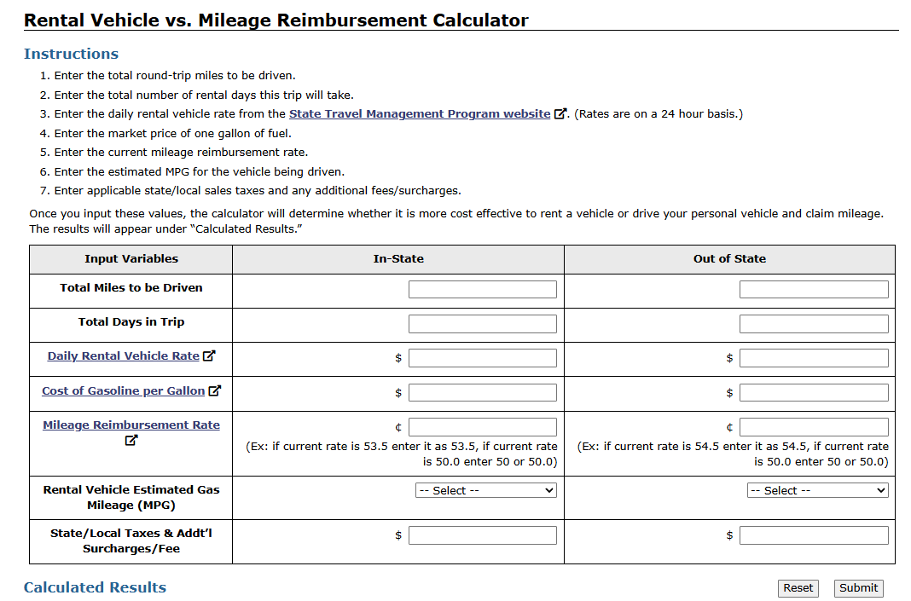

- Complete the fields as follows:

- Enter the total miles you are going to drive for the whole trip;
- Enter the total days in this trip;
- Enter daily rental vehicle rate, if unsure, click the hyperlink, and you will see the list of State contracted rental car companies
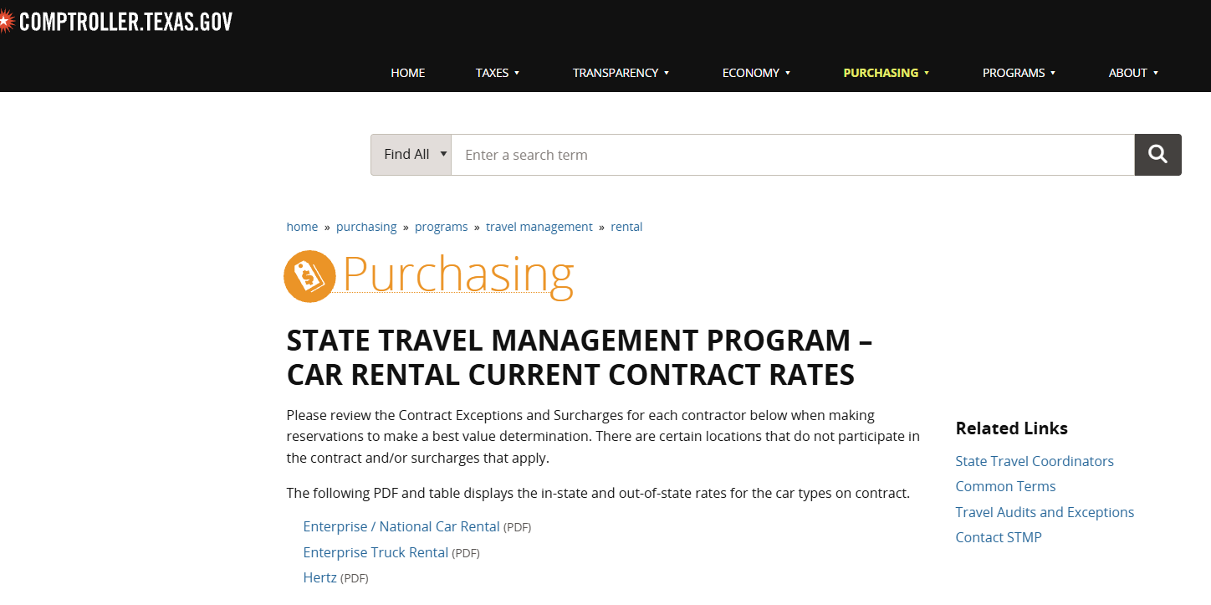
Click one of the vendors and you will be able to see the rate, select “Full Size” class, and put the rate on the calculator page
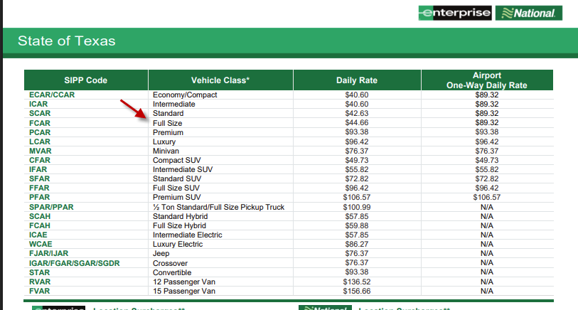

- Enter “Cost of Gasoline per Gallon”, if you ensure, click the hyperlink, select your business destination on the map and you will see the real time gasoline price, enter that number on the “Cost of Gasoline per Gallon” field
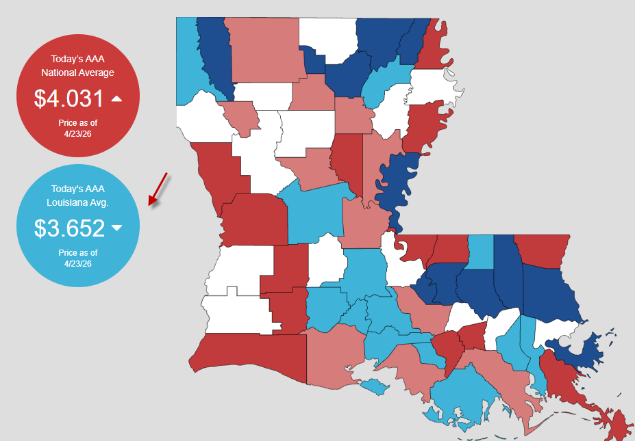

- Enter “Mileage Reimbursement Rate”, for example, enter “72.5” as the rate for year 2026, do not enter “0.725”
- Select MPG from dropdown box
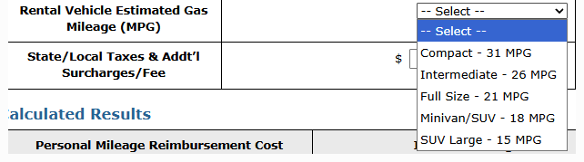
- Add “State/Local Taxes & Addt’l Surcharges/Fee --- this can be found on the State Contracted Vendor Rate
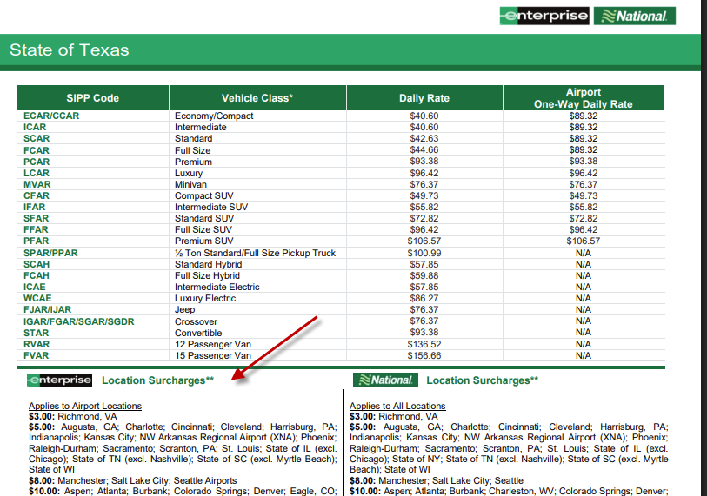

h). After all the information are entered, click “Submit”, and you will be able to see the results
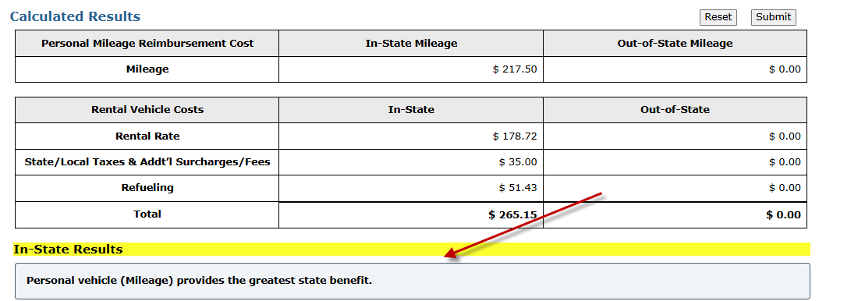

i). You must select the most cost-effective method based on the result
j). The screen snapshot of this calculation must be attached to Travel Request

